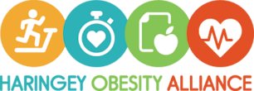
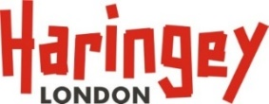
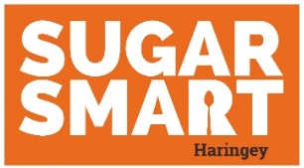

Checklist for Businesses and Organisations
Businesses and organisations are encouraged to make at least one pledge under each action area. Complete one pledge in two action areas within the first year to be awarded SUGAR SMART HARINGEY status. This will be subject to annual review. Send completed checklist to:obesity.alliance@haringey.gov.uk
Action Area 1. Make it easier to choose water and drinks with a very low sugar content
 | Pledge (choose 1 or more) | Available resources
☐ | Join Refill Haringey | - Add a refill station  - Refill marketing Assets  - Children’s Health Fund poster
☐ | Install (more) water points
☐ | Put water / zero sugar soft drinks at the front and/or top of displays to encourage people to choose them
☐ | Provide bottled water for less cost than sugar sweetened drinks
☐ | Introduce a 10p levy on sugar sweetened drinks (and donate the proceeds to the Children’s Health fund)
☐ | Take part in Fizz Free February
☐ | Remove all (or >500ml) bottles of sugar sweetened drinks from sale
Action Area 2. Make healthier food options the easy choice
 | Pledge (choose 1 or more) | Available resources
☐ | Establish sugar-free checkouts | - Healthier vending briefing  - Haringey Food Policy
☐ | Establish low sugar food and no-sugar drinks vending machines
☐ | Provide fruit and/or a healthy option(s) for less than sugary snacks
☐ | Replace sugary items with healthier options
☐ | Ban price promotions on sugary drinks and snacks such as discounts, multi-buys, free items or meal deals
☐ | Create a healthy snacking culture in the workplace by bringing in fruit instead of biscuits and cakes
☐ | Remove large bags of sweets, chocolate and packets of crisps from sale
Action Area 3. Be a healthy eating champion
 | Pledge (choose 1 or more) | Available resources
☐ | Join the Healthy Workplace Charter or Healthier Catering Commitment | - Swap the pop poster  - Sugar content drinks poster  - Healthier Catering Commitment  - Healthy Workplace Charter
☐ | Remove adverts for sugar and make it a policy not to advertise or promote any food / drink high in sugar
☐ | Display signage about sugar content in everyday food and drink
☐ | Promote water and no added sugar drinks
☐ | Display sugar smart messages, campaign materials and posters
☐ | Hold a SUGAR SMART event
Haringey has a sugar problem. High sugar consumption contributes to tooth decay (the biggest cause of hospital admission for ages 5-9) and excess energy intake which causes obesity. Obesity on average shortens someone’s life by 9 years, leads to a 5x increased the risk of type 2 diabetes and 3x increased risk of colon cancer. Haringey children eat 3x the recommended maximum for free sugars. Over 1 in 3 10-11-year-old children in Haringey are overweight and obese, rising to almost 2 in 3 adults. We need your help to create a healthier food environment. The SUGAR SMART HARINGEY campaign encourages everyone to make small improvements which help people to eat less sugar and drink more water. Find out more at www.haringey.gov.uk/sugarsmart .

