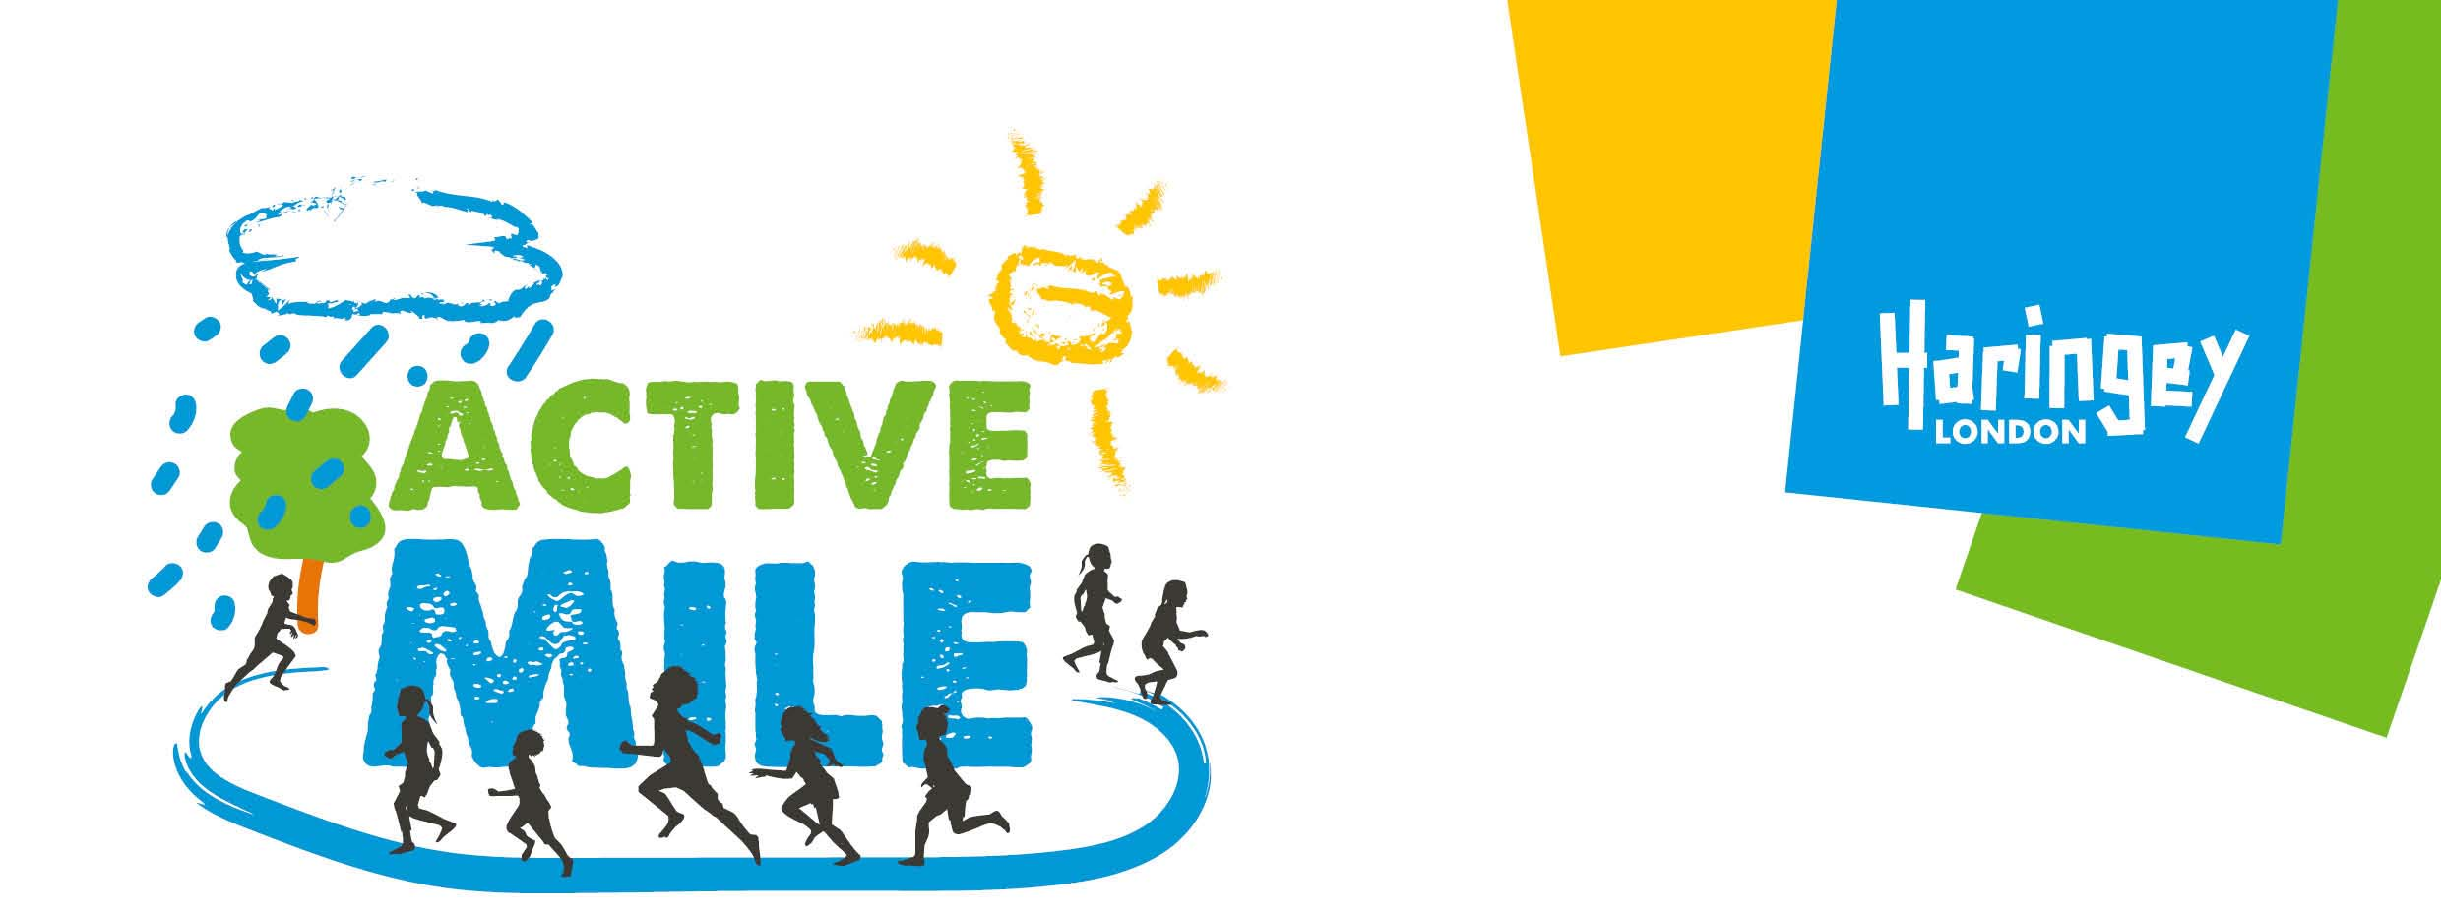
Haringey Public Health have invited Primary Schools to participate in an Active Mile to improve the health and wellbeing of all pupils in the borough.
At <name of primary school or setting> we are going to introduce an Active Mile as part of our regular routine. The aim of an Active Mile is simple – getting children active more by walking, jogging or running for 15 minutes a day.
We are really excited about this new initiative and we are looking forward to the benefits it will bring to your child(ren).

What is an Active Mile?
Active Miles get children outside into the fresh air to walk, jog or run for around 15 minutes in the school playground or nearby park. It includes everyone and is not competitive. It is not PE, sport or cross-country so the children will not need to change their clothes or shoes. It won’t cost any money, and can happen any time of day.

Why are we doing an Active Mile?
You may be aware of concerns around childhood obesity. In Haringey, 1 in 5 reception children and more than 1 in 3 Year 6 children are overweight or obese. Active Miles are recognised as an effective way of tackling childhood obesity. The regular physical activity helps improve concentration, self-esteem and raise children’s attainment. Getting children active now will also help them maintain good health and wellbeing as they grow up.
That’s why Haringey Council is supporting schools to participate in an Active Mile, as part of the Healthy Schools programme.

Where did Active Miles come from?
The government wants all schools to regularly do an Active Mile. Schools who are already doing an Active Mile say that children are fitter and can concentrate more easily when learning.

Is it suitable for young children?
Absolutely! Young children may not manage a mile, but they will still enjoy physical activity, fresh air and the outdoors. Medical opinion suggests that an Active Mile is appropriate exercise for children aged three and upwards.

Is it inclusive of everyone?
Children with mobility difficulties will be supported to fully participate. Other schools have also reported that all children, even those who are reluctant to take part in PE, enjoy doing an Active Mile.
If you have any other questions or concerns, please do not hesitate to contact us.
<contact details for school or setting>

