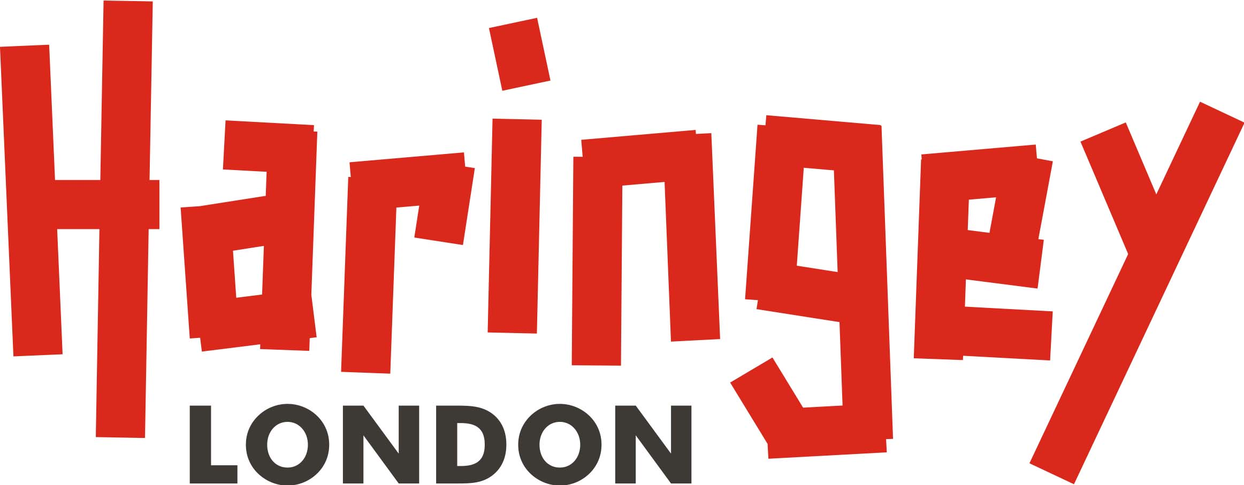
Delegate course booking form
The full legally registered name is required for companies. For individuals, full first name and surname is required. All accounts must have a contact phone number.
1. Delegate details
Full name of delegate
Name of organisation
Private/Voluntary/Charity/Other
Care of or contact name if different
Telephone number (mandatory)
Email address
Delegate postal address

2. Invoice details
SAP customer number (Haringey staff to complete)
Organisation
Contact name
Telephone number (mandatory)
Email address
Postal address

3. Course information
Course title & date:
Course fee
Staff name | Job role | Email address
Course title & date:
Course fee
Staff name | Job role | Email address
Course title & date:
Course fee
Staff name | Job role | Email address
TOTAL CHARGEABLE

4. Course fees

The following charges will apply from 1 January 2021
- Successful eating and drinking: Free
- Communication awareness: Free
- Makaton: £60 for external partners (includes 2 days of training plus manuals)

For other courses, the following charges will apply from 1 January 2021
- Voluntary/Charitable organisations: £10 per person per course. Group discount available for 10 or more bookings
- All other external partners: £15 per person per course. Group discount available for 10 or more bookings

5. Cancellation policy
Haringey Council has a limited training fund and courses will be delivered at optimal occupancy. Punctuality and attendance is key to ensuring delegates benefit from the learning and development delivered by our commissioned providers. To minimise disruption to courses and due to the cost of administration, there is a £50 course cancellation fee/ non-attendance fee per person if less than 5 working day’s notice is given.
This fee may be waived at our discretion. If you need to cancel, cannot attend or have access issues you must:
- Email AdultWorkforce@haringey.gov.uk immediately, and include the course name, course date and the reason you are unable to attend
- If you find a replacement to attend in your place, we may accept a name change and therefore the cancellation fee would not apply

6. Returning the form
By completing this form you agree to the fees and cancellation policy outlined above.
Your name_______________________________________________
Your email address________________________________________
Date____________________________________________________
Please return the completed form by email to AdultWorkforce@haringey.gov.uk

