Apply for an Organisational Blue Badge  Please use this form to apply for an organisation Blue Badge Only.  You’ll need to pay an administration fee of £10 for each Blue Badge once you have received notification that your application has been successful. This must be paid by cheque or postal order made payable to the London Borough of Haringey.  You’ll need to provide a copy of your organisation’s prospectus along this application form.  In all circumstances, badges will be issued to organisations rather than to individual staff members. The badge can only be used when disabled person(s) are present and misuse can constitute a criminal offence which may ensue a fine of up to £1000.  The local authority may refuse to issue a badge if you do not provide adequate evidence that you meet the eligibility criteria. | Return completed form to:  Concessionary Travel  PO Box 55290  London  N22 9GA
1 – Organisation badges  Does your organisation care for people who need a Blue Badge?  Yes  No  Does your organisation transport the people you care for?  Yes  No | If you answer “No” to either of these questions, it is unlikely your organisation is eligible for a Blue Badge.
What’s the name of your organisation?

Charity number (if applicable)

Postal address
(This is where the badge will be posted to)
Postcode:
Who should be contacted about this application?
(If you’re the contact, put your full name here)

Email address (optional) | This will be used for updates about the application.
Main phone number (required)

Alternative phone number (optional)

Section 2 – List the vehicles the badge will be used in
Vehicle registration number | How often is the vehicle used?

Section 3 – Organisations  By submitting this application you agree that:  - you're authorised to complete this application on behalf of your organisation  - the details you have provided are complete and accurate  - you will tell your local authority about any changes that will affect your organisation's Blue Badge entitlement  - your local authority can check any information they already have about you so that they can process your application  I agree to this declaration  Signed  Date of signature  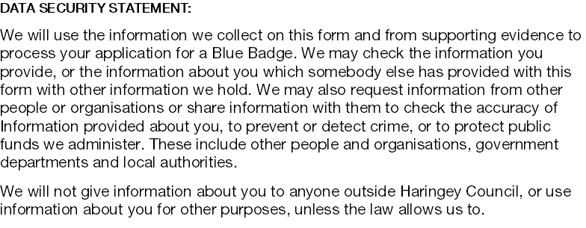 | Read the declaration carefully and only sign it once you are clear.

