Appendix 1 Details of who was consulted:

- Rhodes Avenue School – parents/carers, teachers and governors
- Schools in the local area.
- All Chairs of Governors of Haringey Primary Schools
- Local residents
- Children Service Directors of neighbouring boroughs (Waltham Forest, Hackney, Islington, Camden, Enfield and Barnet)
- Trade Unions
- The local CE and RC diocese
- MPS - David Lammy and Lynne Featherstone
- Active Residents’ Associations
- Haringey’s Transportation Section
- Haringey’s Housing Section

Appendix 2 Minutes of Public meetings

Rhodes Avenue Public Meeting
14th October 2008
3.45pm-5.00pm

3.45pm: Chair of Governors introduced Ian Bailey.

Ian Bailey explains the case for and against expanding Rhodes Avenue.

Comments/questions from audience:

- Bounds Green was reduced from 3fe to 2fe. If Bounds Green already had these places, why disrupt Rhodes? Why reduce Bounds Green if there is a need in the area.
- Bounds Green school can serve area identified on map of consultation document.
- Question around whether Bounds Green school could become as good as Coldfall.
- Are there plenty of places but a shortage of acceptable places?
- Parents rebuff Ian’s comment that Bounds Green does not work well as a 3 form of entry school. Parents argue then why would Rhodes work well at 3 forms of entry?
- Headteacher at Bounds Green School said: Haringey offers way before other authorities. There is a PAN London consultation taking place about admissions systems. Why not wait until the PAN London consultation is completed.
- Headteacher at Bounds Green School asked: Did government money have to be spent by 2011, is that why the focus has been on that year?
- If Rhodes expanded wouldn’t a lot of Bounds Green students want to come to Rhodes? Wouldn’t Coldfall be affected?
- Is the council consulting on expanding St. James CE?
- If Rhodes increases by 200 children there will be another 100 cars. Traffic is horrendous at the moment at 9am. There should be an impact assessment on the local community.
- Since Alexandra Park school increased its capacity there has been an impact on the local community. Can Haringey move the school opening hours?
- Where did the data regarding pupil numbers come from?
- Question to Coldfall Headteacher: Is it overwhelming to have more children in the playground. Is the school sustainable?
- Coldfall Head responds by saying that school is managed by a well organised plan.
- Parents living near Colney Hatch Lane will choose Rhodes over Coldfall, wouldn’t the expansion have a negative effect on Coldfall?
- Coldfall Headteacher says that she concerned about expanding Rhodes when there is some surplus capacity in existing schools already. The proposed expansion creates division and not community cohesion.
- Are we just proving more places to Barnet children?
- Is there surplus capacity in Barnet schools in this area?
- At what stage does the feasibility study happen?
- Is there a minimum amount of space per children?
- Parking is horrendous, crossing the roads is hazardous at 9am. This has increased since the secondary school opened.
- Is the expansion like horse trading? For example will the council only improve the Junior classes if Rhodes Avenue expands.
- Are there any plans to increase school places in the neighbouring boroughs?
- Why not expand one form of entry schools such as St Martin of Porres instead of 2 forms of entry schools? (Anne Pollak)
- Is it not easier to change admissions criteria rather then expand a school? (Anne Pollak)
- How many hours a week are school buildings used? Why not maximise the use of the school, e.g. adopting shift patterns or using Alexandra Park School rather than expanding.
- Is there a demand for Bounds Green to go to 3fe?
- How many first preference applications were submitted for Bounds Green school?
- A Rhodes Governor is concerned about the e-mail sent to community groups. Is it public knowledge about which community groups have been consulted?
- Can you put the community groups which have been consulted on the web?

Rhodes Avenue Public Meeting
14th October 2008
7.00pm-8.40pm

7.15 pm Chair of Governors introduced Ian Bailey.

Ian Bailey explains the case for and against expanding Rhodes Avenue.

Comments/questions from audience

- When will the building plans be available? Parents would like to comment on this before December.
- Are there government recommendations for outside space per head for children? If so, will this requirement still be met?
- Question to David Moore: what is the outside square footage? David to get back to local resident.
- Has consideration been given about the impact of the extra children at the start and end of the day?
- What are the other considerations? For example is reversing Bounds Green from 2fe back to 3fe an option?
- By 2011 will Bounds Green not become more stable?
- If births increase in the area then surely Bounds Green will be affected. Why not increase Bounds Green from 2fe to 3fe. Bounds Green is just half a mile down the road.
- A parent is disappointed that there is no plan of what the school will look like. They would like information on what the impact will be.
- One parent lives in the “dead zone” and would not get a place at Rhodes. She is concerned that proposed school expansion to 3fe is not large enough.
- Who owns the spinney?
- Is there any information available about other school expansions (country wide) e.g. the results, how parents felt and students felt.
- In Haringey’s Primary Strategy for Change document it mentions that we may increase 2 schools by 1 fe, which schools does this refer to?
- Additional school capacity needed for Tottenham Hale, what does this involve?
- Another parent living in the dead zone is concerned that some parents simply rent in the area to get their children into schools.
- One parent asks another parent that if Bounds Green was an attractive option, would she feel so emotive
- Has Haringey done any studies into Bounds Green to see why parents are avoiding this school? (Other parents refute this question, stating that Bounds Green is a popular school.)
- It is a better use of tax payers money to make Bounds Green more attractive then to expand Rhodes Avenue
- What affect will Rhodes Expansion have on Bounds Green?
- A lot of parents do not know about the consultation, especially those living in the dead zone. – Ian said we will publicise 12th November date in the newspapers
- Did the two local church schools want to expand? Are we considering this?
- Seems strange to do a consultation on one school when there are others that want to expand.
- What are the other options? Ian says the 2 church school or emergency options
- Are emergency classrooms in this area or are they in Muswell Hill?
- One local resident said that there is an issue with expanding church schools because of their admissions criteria.
- Are you addressing the dead zones? Expanding the schools in the area around Rhodes is what is need not expanding St Martin of Pores and Bounds Green.
- Councillor Engert:
  - Stressed the need for this consultation and the need to hear the successful experiences of Coldfall
  - Expansions can be positive
  - Has written to the papers to highlight the consultation on 12th November
- Is Alexandra primary school in Alexandra ward? Why is it not on the map? Why are we not making it more attractive?
- Will the design and construction project be phased and how long will it last for?
- How much of existing school will be retained?
- Was a feasibility study done 4 years ago? Could parents have a look at it?
- Has there been a discussion about moving the nursery in Rhodes?
- How do neighbouring boroughs projections impact the school? Ian clarifies that this question is probably referring to admissions, that Haringey issue admission earlier than other boroughs.
- Is there any way of addressing the impact of the secondary school?
- The expansion is divisive in the school and the community. Local resident quotes e-mail Carlene sent that: “no decision has been made, and we are not convinced at this point in time that expansion is necessary or appropriate. “ Questions about whether the expansion is a pointless exercise.
- Understanding that a feasibility study is expensive but one parent believes it is worth spending the money because it is difficult to give comments on something they have never seen.
- There is concern about losing playground.
- The feasibility study will show that Rhodes at 3fe will work but it needs to be in line with the school’s vision.
- Could the expansion involve smaller class sizes?
- Will council only improve junior classes if the school goes to 3fe?
- Is the Primary Strategy for Change one pool of money?
- Will the feasibility study be practical and focus on local area or will it look at how Rhodes at 3fe will work, e.g. staggered breaks.
- Could you use part of the Albert Road Park as long as it is for a soft play area? (David Mores advises that this is something we can explore.) – No we can’t as it’s MOL.
- The feasibility study needs to show achieving benefits.

Rhodes Avenue Public Meeting
12th November 2008
7.00pm-8.00pm

7.00pm: Chair of Governors introduced Ian Bailey.

Ian Bailey explains the case for and against expanding Rhodes Avenue.

Comments/questions from audience:

- The Chair of Governors at St James’, John Lenton explained the case for expanding his school. His arguments were:
  - Educational – 2fe schools are better than 1fe schools. For example, 2 teachers per class means that they can plan better and share best practice
  - Social - St James’ is an outstanding school and they would like to spread this wider into the community
  - Financial – 1fe schools struggle to balance their budgets and have no economies of scale
  - Moral- the Leader of the Council said that St James’ would be natural candidate for expansion. The Local Authority should honour this.
- A parent asked the Chair at St James’s whether the school’s admission criteria would change.
- John Lenton advised that the school would open up and that p 40 places would probably be reserved for church members and 20 opened up to the local community. (Although this has not been confirmed by the governors)
- Is it cheaper to expand St James’s?
- Is it necessary to expand both?
- How much would it cost to expand Rhodes Avenue compared with St James’ and how much would it cost to improve the Key Stage 2 classes?
- What happened to the 47 allocated children? St James’ would give greater choice to people in Muswell Hill but not to those living in Alexandra ward.
- Where did the 47 allocated children live?
- Expanding Rhodes is expensive. What are we doing to invest in other schools in this area so that they can alleviate some of the pressure?
- What are the benefits of expanding Rhodes to 3fe? There is limited space and it will cause disruption.
- How would you carry out the expansion? IB advises that the feasibility study would illustrate this.
- Questions around what the expansion would look like and whether the feasibility study is open to viewing.
- If Rhodes Avenue was 3fe how would this benefit the children’s education? Cllr Engert comments that there have been successful 3fe expansions such as Coldfall
- A parent who lives in the “Bermuda” triangle feels that she is not serviced by any school in the Alexandra area. She expressed concern about not receiving a leaflet about the public meetings.
- There is not a fair representation of people who live in the “Bermuda” triangle.
- Has the council actually communicated directly with the residents?
- General feeling that the leaflets did not work in conveying the message.
- One resident’s son was injured by building works at her child’s school. She feels that 3fes can have a negative impact on children.
- There have been 2 alternatives provided, (the possible expansion of Rhodes and St James C of E). There is a strong case to progress to a feasibility study, consult and weigh up the relevant merits of each case.
- John Lenton agreed that it would be a good idea to conduct feasibility studies at both Rhodes Avenue and St James’ C of E.
- Rhodes Avenue is a special street. It has the secondary school, primary school, golf club and as a result there is a lot of traffic. A group of local residents have formed the Rhodes Avenue Residents Association and question whether it is a good idea to have more primary school children around secondary school age children?
- Does the Local Authority have guidelines around for example distance. A parent governor at Rhodes Avenue feels that expanding St James’ could be a red herring, especially if families have to get the bus or drive to the school. She believes that it would be better to expand Rhodes Avenue.
- There is a lot of traffic on Rhodes Avenue which has increased with the expansion of Alexandra Park school. The Alexandra Park school expansion impeded on parking space for teachers who now park on Rhodes Avenue.
- If St James’s does expand people who live in the Alexandra ward may not go to the school. Parking should not be a major issue in this consultation.
- How much outdoor play space would be sacrificed?
- If you expand Rhodes, what does this mean on catchments? People think that if you expand Rhodes their children will get in and this is not proven.
- Do you have other black hole areas?
- We know that we will be offered a Haringey school, the problem is will we be offered one of our preferences?
- Chair of Nightingale school advises that Nightingale has a lot of work to do to get parents in the Alexandra ward to consider the school as an option. He is concerned that if Rhodes Avenue expands, Nightingale will be negatively impacted.
- One parent asked whether Nightingale is undersubscribed.
- Chair replies, in some years they could take more children.
- How much of the consultation has gone to Nightingale and Bounds Green?
- Is the Local Authority saying that we need to expand in order to improve the quality of the junior classes?

Appendix 3

Responses to Rhodes Avenue Consultation (running from
10th October to the 28th November)

119 individuals or families responded to the Rhodes Avenue consultation, and 8 ‘others’ i.e. Governing Bodies, Barnet LA, the local Police and the Diocese), making a grand total of 126 responses.

The responses from individuals/families (120) were:

Opposed to | 52 (43.3%)
In favour of | 61 (50.8%)
Impartial | 4 (4.1 %)
Inconclusive (did not complete the relevant part of the questionnaire) | 2
Total responses | 119*
*Rhodes Governing Body appeared twice so removed one.

Of the 120 responses, the figures can be summarised as;

Type of response | Number of responses | Number  of Rhodes Avenue Parents | Other* | Unknown
Online questionnaire | 64 | 13 | 51 | n/a
Consultation booklet questionnaire | 25 | 13 | 12 | n/a
Written representations (emails/letters) | 30(2 before consultation start, 3 after consultation closing date. | n/a | n/a | 30
Objections | 52 (of which 21were written reps) | 17 | 14 | 21
Supporters | 61 (of which 10 were written reps) | 6 | 43 | 12
Impartial | 4 (of which 1 written were reps) | 2 | 1 | 1
Missing (i.e. didn’t tick the box on the questionnaire indicating their opinion) | 2 | 1 | 1 | 0
Total | 119 | 26 | 59 | 34
*local residents, parent of a child not yet at school age, member of staff at another school, police, governor at another school, teacher at another school, previous Governor at Rhodes, parents at St James’ and Coldfall

OBJECTIONS
Overall, 52 individuals/families expressed opposition to the proposal. The main points made were:

- Disruption during construction works (including health and safety implications, and impact on local residents.
- Increase in traffic and congestion.
- Impact on quality of the children’s education.
- The school’s unique sense of community will be damaged by the enlargement.
- Credit crunch and current sufficiency of school places means we should not expand.
- Negative impact on Bounds Green Coldfall and surrounding schools.
- Bounds Green has capacity to be 3 forms of entry so expand there.
- Creating more places in a good school will lead to more people moving to the area for school places.
- St James C of E would like to expand so let them go ahead.

IN FAVOUR
Overall, 61 individuals/families expressed support for the proposal, and the following main points were made:

- The importance of allowing children school places close to their homes
- That there is a need for school places in the area
- That a larger school would allow more children to benefit from an excellent school
- The extra places will have a positive impact on the “black hole” that exists where it is hard to secure a local school of choice

IMPARTIAL
4 respondents were impartial about the proposal, and made the following observations:
- Does the projected growth in numbers actually exist?
- Would any required building works actually be completed given the current economic situation?

RESPONSES OTHER THAN FROM INDIVIDUALS/FAMILES

8 representations were received from Governing Bodies of local schools, the Diocese of London Board for Schools, Barnet Council, a Barnet Primary School and the Police. 4 were opposed, 2 were impartial and 1 was in (overall) support of the expansion.

Representations from the Governing Bodies of the following schools were submitted:
- Our Lady’s of Muswell Hill.
- Coldfall primary school.
- St James C of E.

The main objections from these Governing Bodies were:

- Tetherdown, Coldfall and Coleridge have all recently been expanded. Expanding Rhodes Avenue could negatively impact theses schools.
- The consultation lacks information on the impact of expansions that have already taken place
- A harsher economic environment will have an impact on the housing market reducing demand for school places.
- There are no new housing developments planned.
- Bounds Green has the capacity to become 3 forms of entry and expanding Rhodes will have a negative impact on this school.
- Educational - (greater flexibility within the school for specialisation etc).
- Social – (allowing another 30 children to have access to a school of high standards).
- Financial – (economies of scale).
- Moral - (there is a reason for the authority now to consider St James as a very real alternative to the Rhodes Avenue proposal)

An objection from the Diocese of London Board for Schools was submitted. The main objections and concerns of this objection were:

- Local Authorities long standing discussions and commitment regarding the expansion of St James.
- Quality of education – (St James C of E is a popular and successful school and meets the criteria for expansion as set out by the DSCF).
- Popularity of school – (St James C of E is oversubscribed).
- Desirability of a Two Form Entry School – (economies of scale and the feeling that it is better for the Local Authority to expand a one form of entry school than a 2 form of entry school).
- Requirement to keep a balance – ( the Local Authority is required to keep in mind the balance of denominational provision, as recent expansions have been taken place amongst the community schools)

A representation from Rhodes Avenue Primary School Governing Body was received requesting more information. They have reserved the right to express a firm opinion following further information, including the outcome of the feasibility study

Barnet Council also responded commenting that “Overall, we would not have any formal objection to the expansion as there is clearly pressure for places in that area of Haringey. Our only concern would be the impact on Hollickwood School, which is near the Haringey boundary and currently has a number of empty places. Further capacity at Rhodes Avenue would probably only exacerbate this”.

A representation in (overall) support of the proposal from the local Police was submitted. The police said:

“This proposal is good as it meets the needs of the local community; however consideration needs to be given to how the extra pupils will arrive at the school as there are already issues with parking when at the start and end of the school day”.

A representation from a local Barnet School was received – Hollickwood Primary school. They have objected to the proposed expansion on the basis that their school rolls are not full and, because of their proximity to Rhodes Avenue School, any expansion will have a negative impact on their rolls, reducing them still further.

This map is produced using ordnance survey digital map data under licence number 100019199 Copyright © Crown Copyright. No unauthorised reproduction is allowed. (2008) The Children and Young People's Service

Appendix 4 Consultation booklet and leaflet
Consultation on a proposal to
create additional school places in
Alexandra ward
through the expansion of

Rhodes Avenue
Primary School

Friday10 October to Friday 28 November 2008

www.haringey.gov.uk/rhodesconsultation

www.haringey.gov.uk
Why are we consulting you?
This document explains a proposal to create additional school places in Alexandra ward, by expanding Rhodes Avenue primary school to 3 forms of entry (90 reception places). It is written for anyone who has an interest in the school – or other local schools and this proposal. This is the start of the public consultation and you will have a number of opportunities to express your views. The council has not yet made a decision on this expansion and will listen carefully to views expressed in this consultation before doing so.
It is important to note that the responses received by the Council do not constitute a ballot or a vote on the proposal. We weigh views expressed alongside wider educational factors at each stage of the consultation.

Is it right to create new school places by expanding Rhodes Avenue?
There are arguments for and against this proposal.
The case for expansion is that demand for places remains high and projections overall for Haringey shows a continuing rise in primary numbers.
All the schools within Alexandra, Muswell Hill and Fortis Green wards continue to be popular, successful and oversubscribed. In 2007/08 the total amount of pupil place surplus capacity for all schools in these wards was 1%, with only 2 reception places vacant out of the 360 places. First preference applications exceeded those placed by 30 pupils. This provides limited scope for parental preference.

Public Meeting
Rhodes Avenue School Hall Rhodes Avenue N22 7UT
14 October 2008 3.30pm–4.30pm 7pm–8pm
12 November 2008 7pm–8pm
The expansions at Tetherdown and Coldfall have significantly improved the chances of parents applying for the first time being offered one of their local schools. However, some pockets still exist where – at least on first offer – places cannot be offered at local schools, as shown by the shaded area on the map below. These areas are mainly in Alexandra ward, particularly around Rhodes Avenue primary school.
Furthest Distance Offered (On Offer Day) For September 2008.
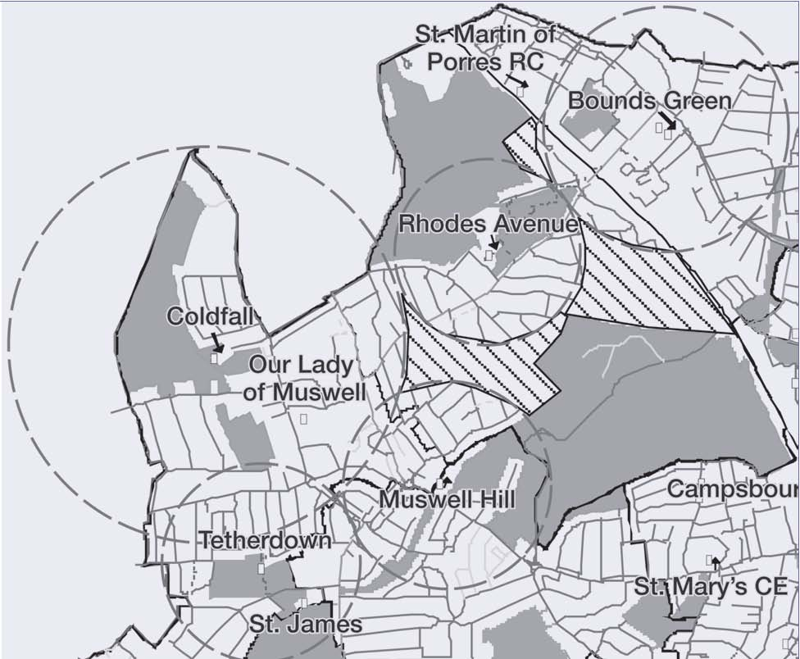
© Crown copyright. All rights reserved LBH 100019199(2008)

Local projections for Alexandra, Muswell Hill and Fortis Green wards do not show a rise, but we believe this is because of the way they are calculated. School roll projections are predominately driven by historical pupil data. As the maximum pupil capacity in an area is reached, schools are unable to increase in numbers which in turn artificially restricts projected growth. All other data indicates an increasing demand for places. Overall Borough Projections are rising and suggest a shortfall of reception places by 2011. Reception admission applications are also on a rising trend.
The danger is if we do not begin to plan now for additional places that may be required by 2011, we could have a serious shortage of places.
On the other hand, there are strong arguments for waiting to see how pupil numbers develop. All projections are predictions and they can be wrong. If we were to expand a school and demand for places did not rise or were to fall we could affect the viability of local schools, seeing them short of pupils and therefore short of funding.
In recent years our predictions have been accurate. On the basis of this we have expanded Tetherdown and Coldfall as well as Coleridge in Crouch End. But these expansions will in themselves affect demand and so affect our projections. Ideally we would wait a few years to see how the recent expansions affected overall pupil numbers in Haringey.
For September 2008, a total of 458 first place reception applications (from across the entire borough) were received by Haringey, for the 360 available places at schools within Alexandra, Muswell Hill and Fortis Green wards. A total of 390 families living in these wards applied for a reception place this September. On 14 March 2008, offer day, (the day offer letters were sent out to parents), 47 families within these 3 wards did not receive a place at any of their preferred schools. There is a period of movement between March and August as families either accept or decline places. This is driven by families moving out of the area, accepting places at private schools or accepting a place in a neighbouring borough, particularly Barnet or Enfield. By 18 August, 39 families had received a place at one of their preferred schools from the original 47 in March, resulting in 8 families still not receiving a place at any of their preferred schools. This suggests that for now there are enough school places, but we will compare the position once we have received admission applications for September 2009. We will also review pupil number information and birth data gathered during the consultation period.
Although there are no new major housing developments planned for these three wards, there are a number of infill developments consisting of 35 bedroom housing. With developments completed since 1996 and known developments planned for the area, the estimated child yield for 016 year olds is to be around 560. However, we are entering this consultation at a time of considerable economic uncertainty. This will have an as yet unknown effect on housing developments and house buying, both of which affect demand for school places.
All options need to be considered when looking at where additional school place provision can be provided. Another option for providing places could be to expanding St James’ CE primary school. We are currently in discussion with the school to evaluate whether this option would meet the needs of the local community – and if additional provision is appropriate.
We need to be sure that any additional school provision in the area is suitable and sustainable for all the schools.
For full details of the figures we are using, see www.haringey.gov.uk/schoolplaceplanning

Why consult now?
Given all the uncertainty, why are we consulting now? This is because of the law relating to school expansions and the time it would take to carry out the building work. Any school expansion requires two stages of consultation:
1. consultation with all interested parties including local schools, followed by a decision to proceed or not to the next stage;
2. formal publication of statutory notices.

If we were to expand Rhodes Avenue for 2011 admission, we need to have the statutory notice period completed by early summer 2009. To do this we must start the consultation now. This consultation is the first stage outlined above. The outcome of this consultation will be reported to the Council’s Cabinet in March. Cabinet will then decide if an expansion of Rhodes Avenue is appropriate.

The proposal
The proposal we are consulting on is that the first 3 form reception entry at Rhodes Avenue would start in September 2011 and that 90 places would be offered in subsequent years. The school would eventually cater for 630 reception to year 6 children, by 2017.
Proposing the creation of additional school places is an important decision for the Council. Before we do so, we make sure that:
■ there is a demand for additional places within the local community;
■ the change can be made in a way that maintains and enhances educational standards at all schools affected by the proposal;
■ the proposal makes best use of resources available, and;
■ there is well established and successful leadership and management.

How can I give my views?
There are a number of ways to tell us your views on this proposal
■ By attending the public meetings, where you will have the opportunity to ask questions on any aspect of the proposal
■ Three public meetings will be held: two on 14 October 2008, at 3.30pm to 4.30pm and at 7pm to 8pm, and one on the 12 November 2008 at 7pm to 8pm in the school hall at Rhodes Avenue, London N22 7UT
■ A copy of this consultation document can be downloaded from the Haringey website where other information about this proposal can also be viewed. There is also an online response form you can fill out: www.haringey.gov.uk/rhodesconsultation
■ By completing the response sheet attached and either handing it in at your school or posting it to:

Carlene Burgess
The Children & Young People’s Service
48 Station Road, Wood Green
London N22 7TY
■ By email to carlene.burgess@haringey.gov.uk
■ By telephone on 020 8489 3607

What happens next?
At the end of this consultation, we will review all the feedback received and the Council’s Cabinet will decide whether or not to move forward to the next phase, referred to as the “statutory representation”.
If the Council’s Cabinet decides that statutory notices can be published, notices explaining the intent to expand Rhodes Avenue primary school to three forms of entry will be published in local newspapers and at the school entrances. The statutory representation period will last for four weeks.
After the end of the statutory phase, a further report will be sent to Haringey’s Admission and School Organisation Forum (HASOF) to consider the results of the consultation and statutory representation. HASOF comments will be forwarded to the Council’s Cabinet, who will make the final decision on the proposal.
Consultation timetable
Timetable | Stage
10 October 2008 | Start of consultation | Consultation
14 October 2008 | Public meetings | Consultation
12 November 2008 | Public meeting | Consultation
28 November 2008 | End of consultation | Consultation
24 March 2009 | Cabinet decides whether to proceed and publish statutory notices | Consultation
31 March 2009 | Publish statutory notices | Only happens if Cabinet decides that the expansion proposal should proceed forward and statutory notices can be published.
30 April 2009 | End of statutory representation period
Mid May 2009 | Proposal forward to HASOF for recommendations
Mid June 2009 | Council Cabinet makes determination on the proposal – if objections are received

Response Sheet
Your views are welcomed on the proposal to expand Rhodes Avenue from 2 forms of entry to 3 forms of entry.
Please complete the response sheet below and hand it in to the school office or return it to the address provided below by the 21 November 2008.
Please tick
the appropriate box that best describes your view.

How do you feel about the proposal to expand Rhodes Avenue school to 3 forms of entry?

Strongly in In favour Impartial Opposed Strongly
In favour view Opposed

Please tell us the reason for your views. In particular what you see as the potential advantages and disadvantages of the current proposal. Feel free to use this space for any other comments on this proposal.
________________________________________________________________________________________________________________________________________________________________________________________________________________________________________________________________________________________________________________________________________________________________________________________________________________________________________________________________________________________________________________________________________________________________________________________________________________________________________________________________________________________________________________________________________________________________________________________________________________________________________________________________________________________________
The Council’s equal opportunities policy requires us to monitor consultation responses and take active steps in ensuring that all of Haringey’s diverse communities participate in public consultation exercises. In order to improve our practices in how we communicate, it would assist us if you can please complete the questions below

In which capacity are you filling out this questionnaire?

(please tick as appropriate))
_______________________________________________________________________



A member of staff at Rhodes A pupil at Rhodes Avenue

Avenue primary school primary school

A parent of a child or children of A pupil at another school
another school

If so, could you please tell us If so, could you please tell us
which one which one

_______________________________________________________________________



A parent of a child or children A member of the governing body
at Rhodes Avenue primary school of another school


A member of staff at another school A member of the governing body
of another school

If so, could you please tell us If so, could you please tell us
which one which one

________________________________________________________________________


A representative of a local A parent of a child or children
community group not yet of school age
If so, could you please tell us A local resident
which one

________________________________________________________________________
Do you represent any other group / body

If so, could you please tell us which one

________________________________________________________________________
11
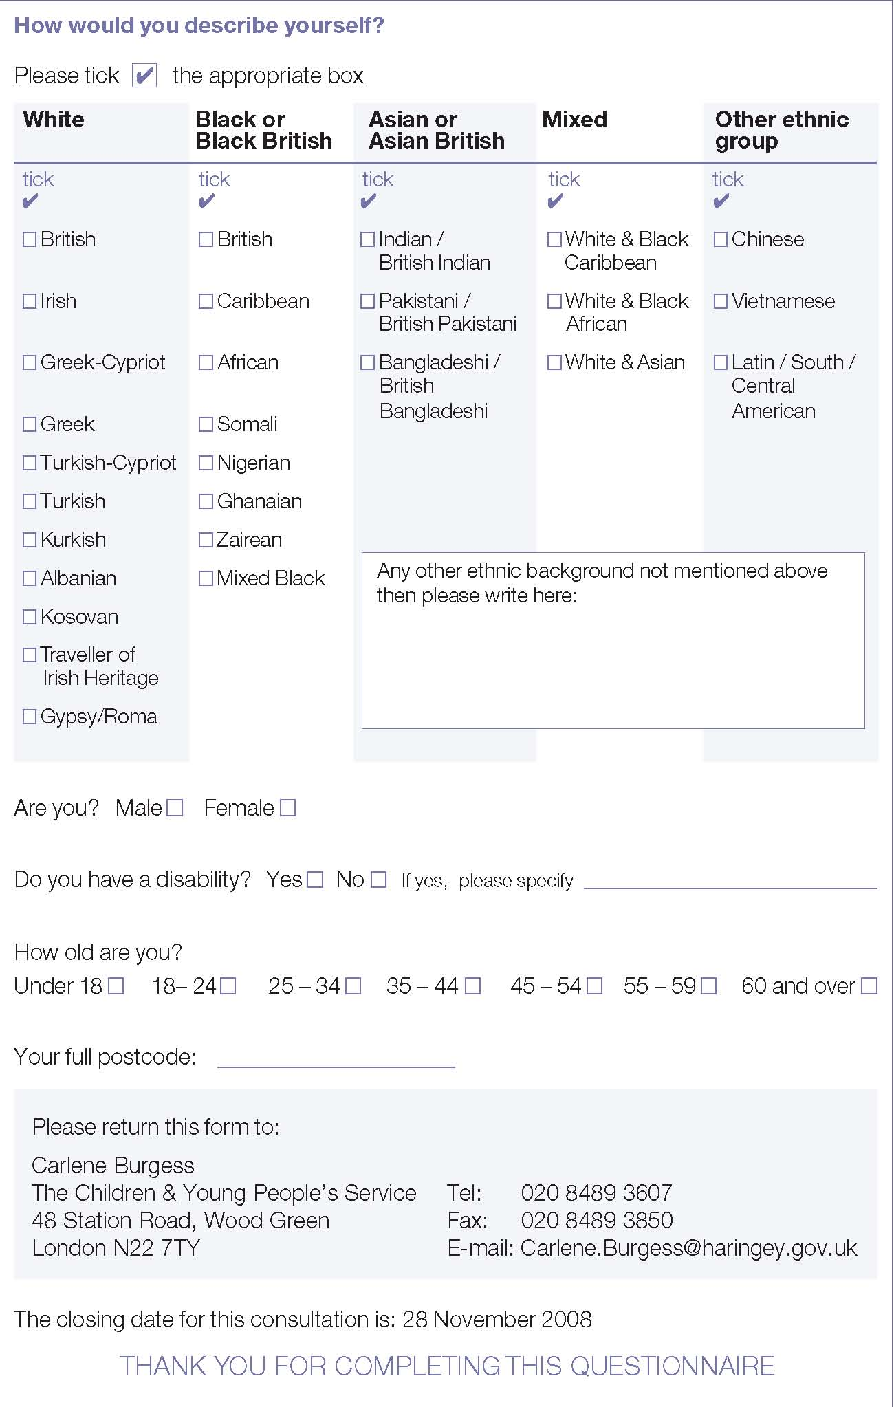
Haringey Council offers this translating and interpreting service to Haringey residents. We can translate this document into one language per resident ONLY. Proposed expansion of Rhodes Avenue Primary School October 2008
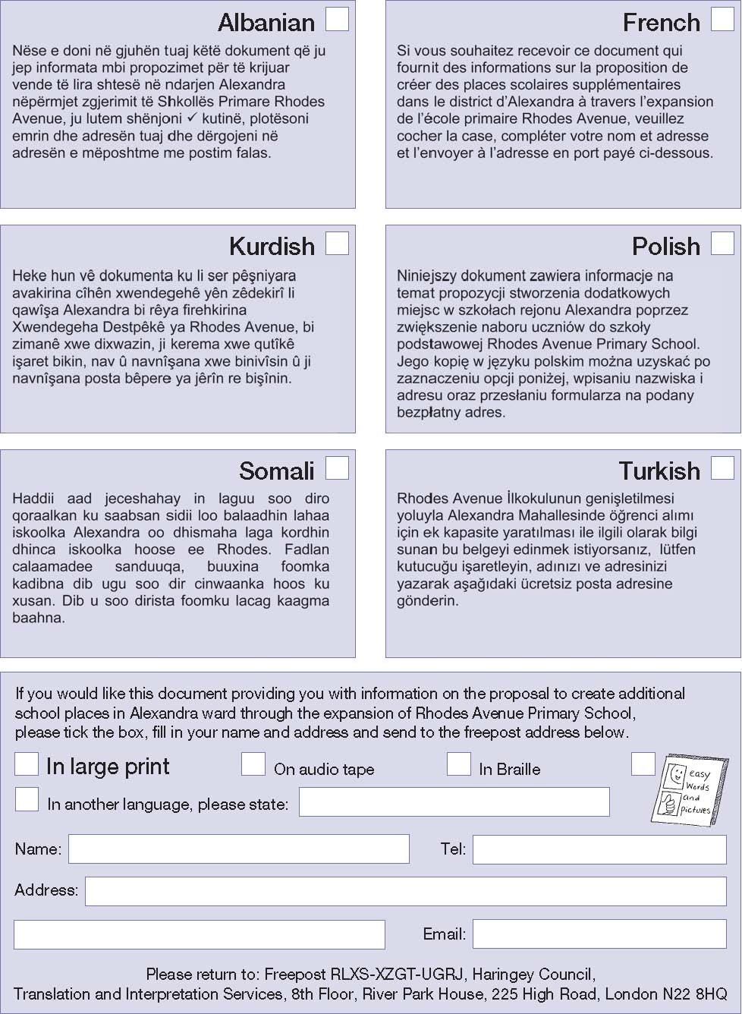

,
Consultation on a proposal to
Published by Haringey Council’s Communications Unit Job No: 20889 10/2008
One tonne of recycled paper saves 17 trees32,000 litres of water, and enough electricity published by Haringey Council’s to heat an average house for 6 months
create additional school places in
Alexandra ward through the
expansion of Rhodes Avenue
Primary School

Public meeting
Rhodes Avenue
School Hall
Rhodes Avenue
London N22 7UT

14 October 2008
3.30pm 4.30pm 7pm 8pm
12 November 2008

7pm 8pm
Friday 10 October to Friday 28 November 2008
www.haringey.gov.uk/rhodesconsultation
Haringey Council
www.haringey.gov.uk
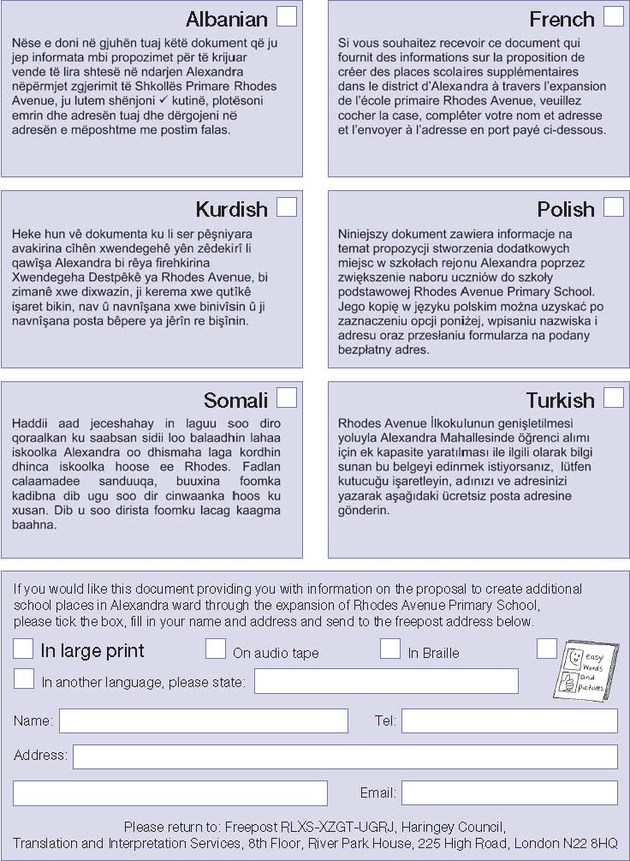
Haringey Council offers this translating and interpreting service to Haringey residents. We can translate this document into one language per resident ONLY.
Proposed expansion of Rhodes Avenue Primary School October 2008
One tonne of recycled paper saves 17 trees,
32,000 litres of water, and enough electricity published by Haringey Council’s
to heat an average house for 6 months Communications Unit Job No: 20889 10/2008

Appendix 5 Cabinet Report 4th March 2009

[No.]
Agenda item:

Cabinet On 24th March 2009

Report Title. School Expansion Consultation – Rhodes Avenue Primary School N22

Report of Peter Lewis, Director of the Children and Young People’s Service

Signed :

Contact Officer : Eveleen Riordan 020 8489 5019 eveleen.riordan@haringey.gov.uk

Wards(s) affected: all, but with particular possible impact on Alexandra, Bounds Green, Muswell Hill, Noel Park, Fortis Green and Woodside wards as they surround Alexandra ward where Rhodes Avenue School is. | Report for: key decision

Purpose of the report
- The July 2008 School Place Planning Report proposed consultation on the possible expansion of Rhodes Avenue Primary School in Alexandra Ward within the West Area Children’s Network from 2 to 3 forms of entry (fe). The consultation on this possible expansion took place between the 10th October and the 28th November 2008. Any expansion would take effect from September 2011 beginning with that year’s reception intake. This report sets out the responses received to the consultation and considers these and all other material considerations and makes a recommendation that the Council should publish statutory notices proposing the expansion of Rhodes Avenue.
- If this recommendation is agreed, a further report will be brought to Cabinet in June 2008 for a final decision to be made.

Introduction by Cabinet Member

We have seen an unexpected and substantial rise in the birth rate in the borough and this trend is replicated in Barnet and Enfield. We estimate therefore that this planning area will need additional reception school places by September 2011 if we are to avoid a situation where we have children with no school place to go to. Within the planning area it is the localities to the south, south-east and east of Rhodes Avenue which are of most concern. I therefore support the recommendation that we expand Rhodes Avenue primary school.

State link(s) with Council Plan Priorities and actions and /or other Strategies:
- The careful planning and control of school places in the borough will contribute to the Council’s Priority 3 “Encouraging lifetime well-being, at home, work, play and learning” and Priority 5 “Delivering excellent, customer focused, cost effective services”.

Recommendations
Members are asked to:
  - Note the feedback from the consultation
  - Note the analysis of other factors influencing the provision of and demand for school places in Haringey and in particular in Alexandra ward.
  - Agree the recommendation that we proceed to statutory notices on the proposed expansion of Rhodes Avenue Primary School from 2fe to 3fe, commencing with the reception intake in September 2011.

- Reason for recommendation(s)
Background

The July 2008 School Place Planning Report recommended the need to consider whether or not to provide additional places in Alexandra Ward. A rising population across the borough means that surplus places in reception classes are reducing generally. Demand is more intense in Planning Area 1 (PA1) than in any other planning area. PA1 comprises Alexandra, Fortis Green and Muswell Hill wards and contains the following schools – Tetherdown, Coldfall, St James’, Our Lady of Muswell and Rhodes Avenue (see Appendix 1 for a map of all of the Planning Areas across the borough).

Our projections, reported in the July report (Appendix 2) showed that, based on birth rates and demand for school places, if we did not take any action, we would run out of school places in across the borough. The Report identified Rhodes Avenue as the school that should be considered for expansion from 2fe to 3fe to meet projected demand. St James’ C of E Primary School have also put forward a body of information and evidence as to why they should be considered over Rhodes Avenue, and this is examined in more detail later in this report. Since that report in 2008 we have had the benefit of three more pieces of evidence – the January 2009 PLASC, the admissions data for September 2009 entry and the latest birth rates for the borough (2006/7). All of the new data that we have confirms the concerns we had for PA1’s school place capacity when balanced against demand and makes the evidence for expansion even stronger.

The 2008 School Place Planning Report set out that a 1fe expansion at Rhodes requires formal statutory consultation as well as substantial building works. The statutory consultation has two main stages: 1) a consultation exercise with all stakeholders, followed by a decision to proceed or not, and 2) formal publication of statutory notices. We would need to begin the first stage of consultation in 2008 in order to meet a timetable for any expansion in 2011. The Report in July 2008 therefore recommended that stage 1 be approved so that we could carry out consultation and report back to Cabinet on the consultation and other material considerations in deciding whether or not we should proceed to statutory notices.

In examining all of these considerations we have been conscious of the need to make a balanced and fair decision based on all of the information before us. If we do not respond to the evidence that points to the need for additional places in this part of the borough we run a very real possibility that we will have insufficient school places to meet demand by 2011. However, if we were to expand a school and demand for places did not rise or were to fall we could affect the viability of local schools, seeing them short of pupils and therefore short of funding. The results of the consultation and all other considerations are set out below under headed sections for ease of reference. They consider material factors across the borough, as well as more local information pertaining to the area around Rhodes Avenue. These considerations include birth rates, admissions data, reception rolls, the current economic climate and the results of the consultation.

Demand for Reception Places and Reception Roll
The demand for reception places in the borough is increasing (see Appendix 2). When looking at rising demand, we have plotted actual births against actual demand for a reception place in the corresponding school year. For example, of the 3844 births in 2002/3, 2932 required reception place when they reached school age in the school year 2007/8. The number of school places available for that year across all of our schools was 3083. This left a 4.90% surplus of reception places across the borough (but only 0.98% in PA1). We need to ensure that there is a balance between assisting schools with their long term financial planning by reducing the number of vacant places, against allowing some real scope for parental preference, and the DCSF accepts that this can be met by allowing for around a 5% surplus capacity at entry across schools. This is not evenly distributed across the borough, however, and PA1 is now in a position where that surplus capacity hovers at around 1%. Looking at population figures and demand for reception places (both real and projected by using figures given to us by the GLA), we have predicted that by 2011/12 we will not have enough reception places to meet the predicted demand across the borough, with the greatest pressure in PA1.

- Reception roll information shows that our reception numbers are rising (Appendix 3). In October 2007 we had 2783 reception children in our schools. By January 2009 this figure had risen to 2991. We currently have the capacity for up to 3062 reception children across all of our primary schools. This figure of 3062 is known as the Planned Admission Number or ‘PAN’

- Admission Applications
Applications to Haringey primary schools are also steadily rising (Appendix 3), up from 2662 on-time applications for reception admission in September 2007, to 2807 applications for admission in September 2009 - an increase in demand for reception places across the borough of 5.2% between 2007 and 2009, i.e. 145 more pupils are seeking a place for entry into primary school for September 2009 when compared with 2007. 145 children represent 4.8 reception classes (145 divided by 30).

- Borough Births
The birth rate for Haringey is also rising – we can see this from actual figures that plot our birth rates dating from 1991/2 through to 2006/7. The GLA also gives us population projections which show how our birth rate is expected to increase or decrease in years to come, right up until 2017/18. Their projections suggest that the birth rate will continue to rise within the borough, as indeed they are predicted to rise across London and the south-east (birth rates in London have risen steadily for the last 19 years).

- Our most up-to-date actual birth figures 2006/7 show that the birth rate for that year across the borough was 4292. This was a rise of 270 births from the figure for 2005/6 which was 4022. At the time that the School Place Planning Report was written in July 2008, we did not have an actual birth rate figure for 2006/7, only a projection. That projected figure was 3983. This means that there have been 309 more births than had been anticipated by the GLA when they projected our figures. Births are therefore rising at a higher rate than we had anticipated when we decided that we needed to plan for additional capacity in reception places in PA1. This is a material consideration in the debate as to whether or not to expand Rhodes Avenue.

- The Economic situation
The impact of the current economic climate on possible birth rate and demand for reception places is a factor that must be given due consideration. The School Place Planning Report 2008 acknowledged that the economic climate or ‘credit crunch’ had to be considered in planning for future school place demand. Since that time we have spoken with the GLA about their evidence, both past and present, of the impact of an economic downturn on the demand for school places in London. The GLA advice is that an economic downturn on its own cannot be a reason not to expand a good school. The evidence in Haringey is that there has been a sharp increase in births since 2005. This sharp increase follows a steadier increase that we have seen year on year for the last nineteen years. Latest actual figures for births in 2006/7 shows that the rise in birth rates has increased further than was projected, and has exceeded the projections that the GLA made for our birth rates. The children born in 2006/7 will enter reception class in 2011/12, and they represent a rise of approximately 10% on those born in 2003/4 (who entered reception in 2008/9). Latest provisional birth figures across England for the first half of 2008 show that births were up by nearly 5% when compared with the first half of 2007. So, while there may be a downturn coming, figures have not yet borne this out.

- A further aspect of recession is the additional numbers entering reception classes due to the collapse of the housing market. The GLA would normally expect (and Haringey’s figures bear this out) that many parents of pre-school children move away from London and so dilute the crude birth numbers before that cohort enters school. Evidence presented to the GLA Demography Liaison Group in October 2008 shows that this does not seem to be happening at the same rate as before as families are trapped in homes that they cannot sell, or they are not willing to move to a larger home outside of the capital because of uncertainty around retaining their employment and therefore earning ability.
- There has been some national evidence that the economic downturn has had a negative impact on the demand for private school places, which in turn has led to increased demand for state school places. We do not have any empirical evidence for Haringey. The Economist (22nd January 2009) has indicated that the funds available to prop up private school fees at the last recession, including sale of property and Grandparent investment returns, are less readily available in this recession, and so there may be a greater impact in terms of those taking their children out of private education and putting them into state education. It remains to be seen how this plays out. The Guardian (11th February 2009) has reported that The Headmasters and Headmistresses’ Conference (Feb 2009) had indicated that independent schools are defying the slump at the present time, but commentator’s have predicted that the effects of the recession might not be felt on independent schools for another year or two. In conclusion, we need to continue to monitor the effect of the economic downturn. Current evidence does not suggest that, so far, it has meant a reduction demand for school places within the borough, or indeed within the area that is local to Rhodes Avenue, and GLA advice is that a recession may actually result in an increased demand for school places as people are stuck in their homes and unable to move.

- Births in and around PA1
Appendix 4 shows the births rates broken down into the fourteen Planning Areas across the borough. The birth rate for PA1 in 2005/6 (the cohort of children who will enter school in 2010/2011) increased by 33 births in one year i.e. the equivalent of just over one reception class. Even allowing for some of these families to move away from the borough and not demand a school place in 2010/2011, this represents a substantial increase in the number of children who are likely to come forward in that year for a reception place. Further, the GLA have indicated that there is likely to be less mobility of pre-school families during an economic downturn. With reception classes very nearly at or at full capacity, there are almost no surplus places for these children to fill in PA1. PA1 is surrounded by PA2, PA3, PA13 and PA14. The demand for and supply of school places in these planning areas has a bearing on PA1 (and vice versa), even allowing for the fact that parents will have preferences for where they want their children to go to school.

Year of  birth | Equivalent  year for  entry into  reception | PA1 | PA2 | PA3 | PA13 | PA14
2005/6 | 2010/11 | 458 | 155 | 368 | 214 | 405
2006/7 | 2011/2012 | 491 | 146 | 420 | 201 | 443

- Of these Planning Areas, PA14 (containing St Martin of Porres, Bounds Green, Earlham, Nightingale, St Michaels CE and St Pauls RC) is probably the most relevant Planning Area as it contains the schools (particularly Bounds Green) that are sited closest to Rhodes Avenue School. The birth rate in PA14 has risen too, up by 38 births (9.4%) from 2005/6 to 2006/7. Birth rates are also up (by 14%) in PA3 but down in PA2 (5.8%) and PA13 (6.1%) for the corresponding period. Overall the net gain in births across all of these Planning Areas is 101 children, equivalent to over 3 reception classes.

- Local Situation in PA1 – Reception Rolls and admission applications
Appendix 5 shows the number of pupils who are currently in reception across PA1. Rolls in PA1 are high with close to 0% surplus capacity across the schools in this area. We have also looked at admission applications for reception for the last four years. This information takes us up to those children who will be starting school in September 2009. This information is set out in Appendix 7. The admissions data shows that the number of applications has remained fairly steady over the last few years at around 450.

- Dry Runs
We have been able to carry out ‘dry runs’ on the admissions data that we have for September 2009 entry. These runs give us an indication of which schools the children that have applied to school will actually be offered. We have also created a dry run on the assumption that Rhodes Avenue would be 3fe in 2009. This enables us to look at the impact that the expansion of Rhodes Avenue would have on surrounding schools at a particular point in time i.e. September 2009 (two years before the proposed expansion of Rhodes Avenue which is scheduled for 2011). The advantage of a dry run is that it gives us some indication as to what would happen to school rolls in the area. There are limitations on carrying out a dry run however. These include: 1) not knowing if those families who have applied to church schools will meet the criteria and therefore whether they will get into those schools or will require a place at another school; 2) not knowing if all of the offers made to pupils will be accepted – some families may opt to go to school out of borough or privately, or may move before they are due to take up a place. The dry runs suggest that, even on 2009 numbers of applications, expanding Rhodes Avenue would not significantly affect offers to other local schools.

- Consultation
As part of the decision making process on whether we should proceed to statutory notices with the expansion of Rhodes Avenue to 3fe, the Council carried out consultation with local schools, parents, residents and other interested parties. This consultation was carried out between the 10th October and the 28th November 2008. The start date of the consultation was delayed from the end of September 2008 so that it did not clash with the local bye-election that was being held in Alexandra Ward. As part of that consultation we held three public meetings. Appendix 9 sets out in detail what the response to the consultation was. Overall, the response was fairly even with a similar number of responses being for and against the expansion. Those against the expansion cited issues including:

- Disruption during construction works and impact on local residents
- Increase in traffic and congestion at drop off and pick up
- Impact on the quality of the children’s education
- The school’s unique sense of community will be damaged
- Credit crunch and current sufficiency of places means we should not expand at the current time
- Negative impact on surrounding local schools
- Expand other local schools to 3fe where there is existing physical capacity to do so
- Creating more places in a good school will attract more people to the area demanding school places
- St James C of E would like to expand so let them.

Those in favour of the expansion cited the following reasons for support:

- The importance of allowing children school places close to their homes
- There is a need for additional school places in the area
- A larger school would allow more children to benefit from an excellent school
- The extra places would have a positive impact on pockets of the local area where it is hard to secure a local school of choice

- We also received 8 responses from Governing Bodies of local schools, the Diocesan of London Board for Schools (C of E), Barnet Council, a primary school in Barnet and the Police.

The Chair of Governors from St James’, supported by the Director of the London Diocesan Board for Schools (Anglican), has made a case for why we should be expanding St James from its current 1 fe to 2fe to provide additional school places in the area as an alternative to the Rhodes Avenue proposal. In addition, the Chair addressed one of the public meetings that were held to set out why he considered that St James should be the first choice of school for expanding in the local area. He set out a four-fold case for St James:

- Educational: two teachers per year group allows an experienced teacher to be harnessed with an NQT, and also allows for greater flexibility in teaching different subject matters;
- Social: year on year St James receive three applications for every place, and so some local families are disappointed. Expanding to 2fe would allow a further 30 children a year to have access to a school that is rated as “outstanding” by Ofsted.
- Financial: as a 1fe St James struggles yearly to avoid budget deficits, and there are no economies of scale available. Expanding to 2fe would enable the school to cover its fixed overheads much more readily, making budget balancing easier while continuing to achieve strong results.
- Moral: in 2003/4 a possible St James’s expansion failed to meet the DFES deadline, and the Council’s Leader at the time publicly undertook to look at St James’ as the next natural candidate for expansion next time places were needed in the area. The School and the Diocesan Board have stated that this undertaking has not been honoured.

- We have listened very carefully to the reasons that have been put forward by St James for their school to expand as opposed to Rhodes Avenue. There are two factors that have led us to conclude that, at the present time, St James should not be the school in PA1 that is expanded. Both of these reasons centre on demand and supply. Firstly, we have looked at the latest admission applications that we have for September 2009 entry, and we have also looked at admission data for preceding years. The overall picture for admission applications in PA1 (where both Rhodes Avenue and St James are situated) is an upward trend with first preference applications up from 409 across the planning area in 2006 to 451 for September 2009 entry (an increase of 9%). First preference applications for St James between 2006 and 2008 averaged 37. However, the applications for entry in September 2009 have shown a marked drop – with only 19 families placing St James as their first preference (0.6 applications for every available place). Based on this information, we are not confident that the case for St James as a sustainable 2fe school at the present time is as clear as the case for Rhodes Avenue as a sustainable three-form entry school. Linked to this is a geographical analysis of where the demand for places is that is not being met, and the admissions criteria. Residents have labelled an area to the south, south-east and east of Rhodes Avenue as the ‘black hole’. This is an area where it is less likely that parents will secure any of their preferences. St James’ is to the south-west of this area, some distance away from the so called ‘black hole. This is also the area that the Council identified when we made our decision to explore the need for additional school places in the area.

- Pressure for school places has been somewhat relieved in this part of the borough in recent years by the expansion of Tetherdown Primary school from 1fe to 2fe, and, to a lesser extent, by the expansion of Coldfall Primary from 2fe to 3fe. However, some pockets still exist where – at least on first offer – places cannot be offered at local schools. At Appendix 6 is a map that shows these pockets by a shaded area. These areas are mainly in Alexandra ward, particularly around Rhodes Avenue primary school. Added to this uncertainty as to whether St James’ is the right school to expand is the admissions criteria for the school. St James’ is a C of E school and the admissions criteria differ from other local (non-denominational) schools. St James’ places ‘church commitment’ as criterion 4 on its Admissions Criteria for 2009 entry. This means that it is likely that applications for the school will come from a wider geographical area. Based on the evidence admissions applications for St James’ for 2009 entry and the local areas generally where there is very short supply of reception places, our current concern would be that the admissions criteria would not allow supply to be directed to those parts of PA1 where it is needed. Rhodes Avenue is geographically placed in a more appropriate position to meet the areas where there is greatest shortfall in the supply of preference places.

- Other Local Schools
In considering the expansion of a school, regard must be had to the potential impact of that expansion on surrounding schools. One of the Principles of School Place Planning that were first outlined in the School Place Planning Report 2005 is that we must have “regard for the impact of any changes on the viability and standards at existing and new schools. The public meetings were attended by several local head teachers, and two of the local schools, St James’ and Our Lady of Muswell, have written to us expressing views on the possible expansion. St James’ views have been clearly outlined above and they opposed to the expansion for the reasons as set out in 5.20 above. Our Lady of Muswell (OLM) has also expressed opposition to the proposal. Their Governors have commented that they do not believe that the proposal for additional places in Alexandra ward is supported by sufficient evidence of projected demand. It is their view that the recent additional expansions in places are now beginning to impact the system, and are adequate to address the present and foreseeable demand. They have further commented that “the number of applications for Our Lady of Muswell this year (2008 entry) has decreased from previous years” and that they “do not believe that the proposal for additional places in Alexandra ward is supported by sufficient evidence of projected demand. Indeed, it is our view that the recent additional expansions in places are now beginning to impact the system, and are adequate to address the present and foreseeable demand. They conclude by saying that: “It is our view that to proceed to create additional places will, as the Consultation concedes, increase the risk of existing places at other schools not being taken up, with the consequential adverse impact on funding for those schools”. Admission applications data for September 2009 admission show that OLM has had an increase in demand, up from 56 first place preferences in 2008, to 62 first place preferences for 2009. Further, OLM’s objections need to be balanced against other evidence, including an actual birth rate that exceeds all projections. The local Barnet school, Hollickwood, have expressed concern at an expansion because of the potential impact on their school rolls. However, Barnet have indicated that birth rates in their borough are rising, and that first preference applications for Hollickwood are also rising (see para. 5.22 below).

Cross Borough Issues
We have spoken to the two neighbouring authorities, Barnet and Enfield, to ask them to tell us about their school place planning in the area immediately adjacent to the boundary with Haringey, and close to Rhodes Avenue Primary School. Neither borough expressed an objection to the proposal, although Barnet did comment that: “we would not have any formal objection to the expansion as there is clearly pressure for places in that area of Haringey. Our only concern would be the impact on Hollickwood school, which is near the Haringey boundary and currently has a number of empty places”. They went onto conclude that: “although we are concerned about Hollickwood, we understand the need for Haringey to look at this expansion and would not object to it going ahead” since they have made those comments, both boroughs have been in receipt of two important pieces of information: the September 2009 admission data and the latest birth rates from the GLA. As a result of this we have spoken again to Barnet. They have told us that there has been an upward trend in demand for places at Hollickwood primary – up from 17 first place preferences in 2008 to 25 first place preferences for 2009. Their birth rates have also risen – births in 2006/7 (i.e. children who will enter reception in 2011) have jumped by more than 28%. One can expect that this will result in an increased demand for school places in that year, even allowing for families that might move away from the area in the intervening years.

- Enfield too has confirmed that their birth rates are rising and they are facing very real challenges in the provision of reception places across the borough. They have already experienced a shortfall between demand and supply which has necessitated some temporary classrooms and a programme of school expansion. within the area close to our boundary they have indicated that the recent North Circular Area Action Plan (NCAAP) could provide up to 2000 new residential units along the North Circular Road (NCR) in the next 5 -10 years. Enfield are keen to see a large portion of these units in the form of family housing with the resultant impact on demand for school places. Bowes Primary, situated just over the borough boundary, currently provides places for 90 Haringey children. As part of the NCAAP, there is a proposal to move Bowes primary to the other side of the NCR onto the Broomfield (Secondary) School site which would take it further from the borough boundary and make it less likely that Haringey children would gain a place there. Some of these families are likely to look to Bounds Green and Rhodes Avenue for places. Finally, the Ladderwood Estate and surrounding area to the south of Garfield school (in Enfield) is being redeveloped, with the replacement of small flatted units with more family type accommodation. Again, this has potential for an increased demand for school places. Even if Enfield are able to contain this demand within its own schools, the increase pressure will mushroom out across the borough boundary and is likely to affect demand in our schools.

Other options considered

  - We have given consideration to two other options. The first is to leave Rhodes Avenue at 2fe and to expand St James’ C of E Primary School from 1fe to 2fe. However, as discussed in paragraph 5.13 above, we have concerns that an expansion of St James’ would not meet the demand for school places in the part of the borough experiencing the greatest pressure. Further, latest admissions applications data gives us concern that demand for St James’ as a sustainable 2fe school is not proven. We have looked impartially at the cost of expanding St James’ and not expanding Rhodes Avenue and have concluded that there is no economic advantage of expanding one school over the other.

  - We also have the option to do nothing – based on data available in 2008, we predicted that if we did not take action, that we would run out of school places in the local area by 2011. More recent data, including birth rates, admission app0lciations and the January PLASC, gives added weight to these fears.

- Summary

  - The 2008 School Place Planning Report drew attention to the increase in demand for reception places in and around Alexandra Ward and the rising rolls across all schools in this area. when viewed with the rising birth rates across Haringey and the lack of choice that parents in this area have in selecting a school, it was agreed that the Council would carry out consultation on the possible expansion of Rhodes Avenue Primary School from 2fe to 3fe, and to carry out further work and research on the demand for and supply of school places in the area.

  - The consultation was carried out between October and November 2008, and its conclusions were fairly evenly split both for and against the expansion.

  - Since the School Place Planning Report was written, we have had the benefit of three more important pieces of data: the January PLASC, the admissions applications data for entry into primary school in September 2009 and the latest birth rate data (covering 2006/7) from the GLA. All of this evidence supports our initial view that we may need to expand a school in the local area, or risk running out of school places by 2011.

  - Following very careful consideration of all material facts, and examination of the alternatives to expanding Rhodes Avenue, we are of the opinion that we will require additional school places by 2011 and recommend that we proceed to the publication of statutory notices in April 2009, together with a further round of consultation with parents, local residents and interested parties.

Chief Financial Officer Comments
  - Through the Dedicated Schools Grant (DSG) the authority receives funding, and is in turn obliged to fund its schools, based on the actual numbers of pupils on roll at the time of the January PLASC count. In a stable environment it is possible for schools to plan class organisation to match as closely as possible pupil numbers regardless of the theoretical admission number(s).

  - However, schools often experience financial planning difficulties where there are surplus places in an area (as this maximises parental choice and planning uncertainties). Such difficulties are acutely felt in 1FE schools where the scope to merge classes and cover fixed overheads is particularly affected by downward pupil number fluctuations.

  - The School Forum has recommended, and Cabinet has agreed, to changes to the Haringey Formula for Financing Schools in 2009-10 to increase the lump sum allocations to 1FE schools in recognition of some of these difficulties.

  - In summary the risks that need to be balanced in this proposal relate to the possible inefficient use of capital resources and the potential effect on surrounding schools if demand was not as predicted, leading to surplus places being created.

Head of Legal Services Comment
  - The Head of Legal Services has been consulted on the content of this report. Section 14 of the Education Act 1996 requires the authority to secure that there are sufficient schools for providing primary and secondary education in its area. Consideration of the data set out in the report should be undertaken with this duty in mind. While this is not an issue for the determination of this report, the authority will need to bear in mind the duty to respond to parental representations concerning the provision of schools introduced by Section 3 of the Education and Inspections Act 2006. The School Organisation (Prescribed Alterations to Maintained Schools) (England Regulations) 2007 (as amended) state that all interested parties as specified in Schedule 5 Part 2 should be consulted in relation to any expansion. Section 176 of the Education Act 2002 also provides that Local authorities should consult pupils on the expansion that may affect them. In terms of the statutory proposals it must include the prescribed information as specified in Schedule 5 Part 1 of the School Organisation (Prescribed Alterations to Maintained Schools ) (England) Regulation 2007 (as amended). A statutory notice including details of the proposals with details of how copies of the proposals can be found must be published in a local newspaper and also be posted on all entrances of the school and at another place in the area such as a local library of post office. Regard should be had to Schedule 5 Part 2 section 28 the School Organisation (Prescribed Alterations to Maintained Schools (England) Regulation 2007 (as amended) which sets out the process for publication of proposals.

Equalities &Community Cohesion Comments
  - Providing local school places to meet local demand helps to contribute towards the development of sustainable communities.

Consultation
  - Alongside the publication of Statutory Notices on the proposed expansion, the Council will carry out a further four week period of consultation with local school, residents and other interested parties running during April 2009. The results of this consultation will be fed back to HASOF in May 2009 as part of the report recommending whether or not the expansion should proceed. If there have been objections to the proposal, the consultation will also be reported to the July 2009 Cabinet who will make the final determination on the expansion.

Service Financial Comments
  - Current estimates based on early feasibility work are that the cost of expanding Rhodes Avenue, taking account of other works to address suitability and conditions problems (most of which would need to be attended to in any event) would be £8.4m. This project is to be funded from Primary Capital Programme resources recently approved by the DCSF (subject to minor amendments), and has been included in the capital programme budget for 2009/10 – 2011/12.

  - In common with most London Boroughs, we have submitted information to the DCSF through London Councils to show that further funding will be needed in coming years to meet other primary place needs. Haringey has put forward a case for a further £18m to provide for additional capacity by 2015.

Use of appendices /Tables and photographs
Appendix 1 - Map of Haringey School Planning Areas (PA1 – P14)
Appendix 2 - Provision of primary school places
Appendix 3 - Total Reception Rolls and Demand for Reception places
across the Borough
- Appendix 4 - Birth Rates by Planning Area
Appendix 5 - Number and surplus capacity of children in reception across PA 1.
Appendix 6 - Furthest Distance Offered (On offer Day) For September 2008
Appendix 7 - Primary Admission Applications 2006-2009

Local Government (Access to Information) Act 1985
  - School Place Planning Reports 2007 and 2008
GLA roll and birth rate projections
Haringey PLASC returns
The Economist – January 2009

Appendices

Appendix 1 Detailed information about Planning Areas 1-14

To enable manageable analysis and planning, primary school roll data is provided in localities. As in the 2005 report the borough has been split into 14 planning areas. Each corresponds to one or more wards (the Greater London Demography system does not permit more than 14 areas).
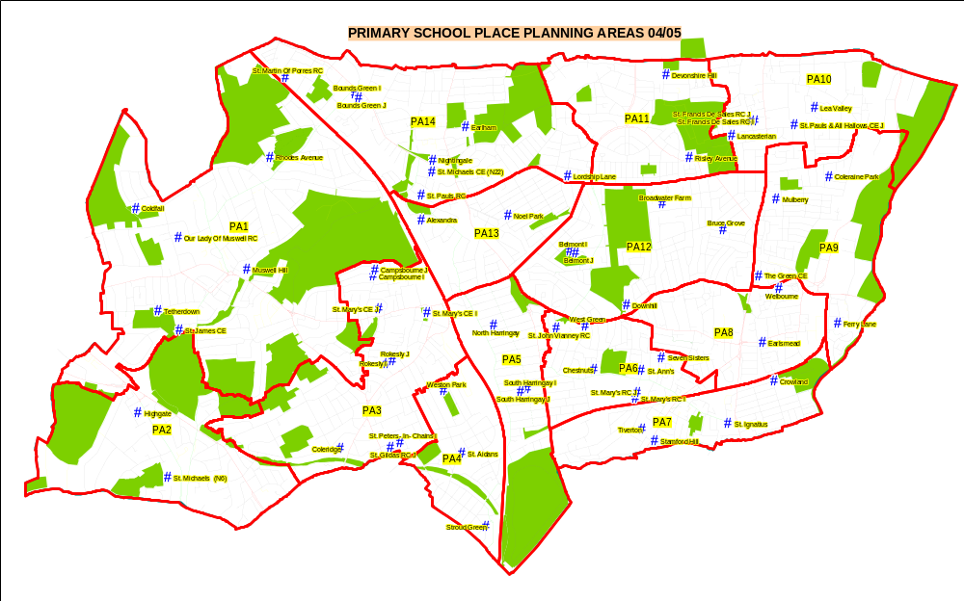

Appendix 2 Provision of primary school places

The GLA projections show an increasing demand for places at reception. This is driven by two related factors: the increasing birth rate and the continuing high level of housing development in and around the Borough. If actual experience follows the projections we can expect that by September 2010 the number of reception aged pupils could exceed the number of school places available at reception. For this reason it would be prudent to plan for additional capacity within our schools.

Intake year | Actual & projected births applicable for that cohort intake | Actual (1996-2007) & Projection (2008-2017) reception aged pupils | PAN figure | % of reception surplus
1996/97 | 3386 | 2919 | 3020 | 3.34%
1997/98 | 3397 | 2849 | 3020 | 5.66%
1998/99 | 3396 | 2835 | 3020 | 6.13%
1999/00 | 3372 | 2880 | 3050 | 5.57%
2000/01 | 3474 | 2943 | 3071 | 4.17%
2001/02 | 3635 | 2978 | 3050 | 2.36%
2002/03 | 3581 | 2849 | 3050 | 6.59%
2003/04 | 3652 | 2820 | 3080 | 8.44%
2004/05 | 3689 | 2840 | 3059 | 7.16%
2005/06 | 3777 | 2855 | 3089 | 7.61%
2006/07 | 3759 | 2899 | 3119 | 7.05%
2007/08 | 3844 | 2932 | 3083 | 4.90%
2008/09 | 4021 | 2973 | 3062 | 2.91%
2009/10 | 3943 | 3004 | 3041 | 1.22%
2010/11 | 4022 | 3066 | 3041 | -0.82%
2011/12 | 3983 (projection) | 3073 | 3041 | -1.05%
2012/13 | 3984 (projection) | 3075 | 3041 | -1.12%
2013/14 | 4004 (projection) | 3100 | 3041 | -1.94%
2014/15 | 4031 (projection) | 3131 | 3041 | -2.96%
2015/16 | 4058 (projection) | 3159 | 3041 | -3.88%
2016/17 | 4076 (projection) | 3162 | 3041 | -3.98%
2017/18 | 4082 (projection) | 3178 | 3041 | -4.51%

Appendix 3 Total Reception Rolls and Demand for Reception places
across the Borough

Reception roll information shows that reception numbers in our schools are rising.
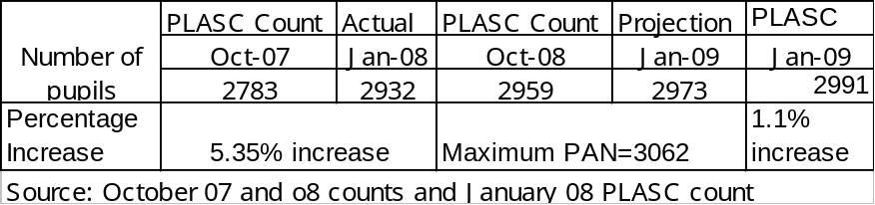

Demand for Reception places across the borough

The numbers of applications for reception are also rising.

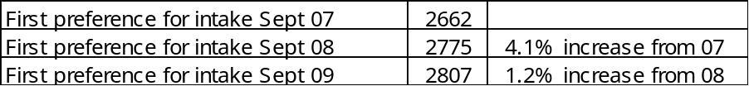

Appendix 4 Birth rates by Planning Area

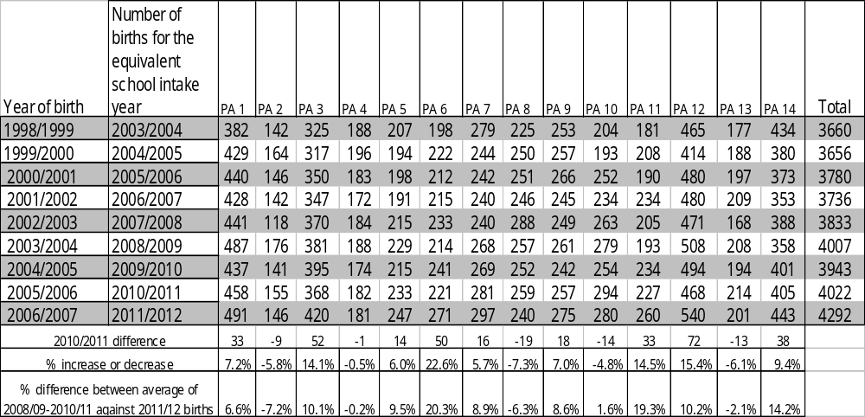

Appendix 5 Number and surplus capacity of children in reception across PA 1.

The schools across planning area 1 are full with very little surplus capacity.

Name of School | Reception numbers by year
Name of School | 2007 | 2008 | 2009
Coldfall | 86 | 89 | 90
Our Lady of Muswell RC | 60 | 59 | 56
Rhodes Avenue | 60 | 60 | 60
St. James CE | 30 | 30 | 30
Muswell Hill | 60 | 60 | 60
Tetherdown | 60 | 60 | 60
Total | 356 | 358 | 356

Name of School | Surplus Capacity
Name of School | 2007 Surplus | 2008 surplus | 2009 surplus
Coldfall JMI | 4% | 1% | 0%
Our Lady of Muswell RC | 0% | 2% | 7%
Rhodes Avenue | 0% | 0% | 0%
St. James CE | 0% | 0% | 0%
Muswell Hill | 0% | 0% | 0%
Tetherdown | 0% | 0% | 0%
Total | 1.1% | 0.6% | 1.1%

Appendix 6 Furthest Distance Offered (On offer Day) For September 2008 – shaded area shows pockets where
Families were not offered any of their preferences

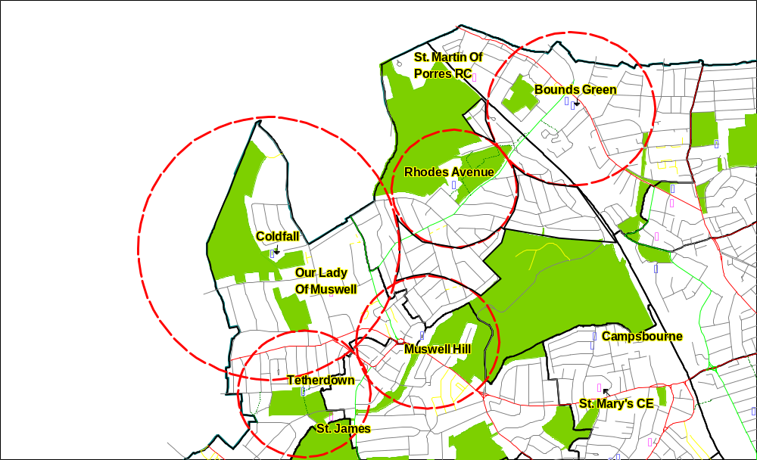

Appendix 7 Primary admissions applications 2006-2009

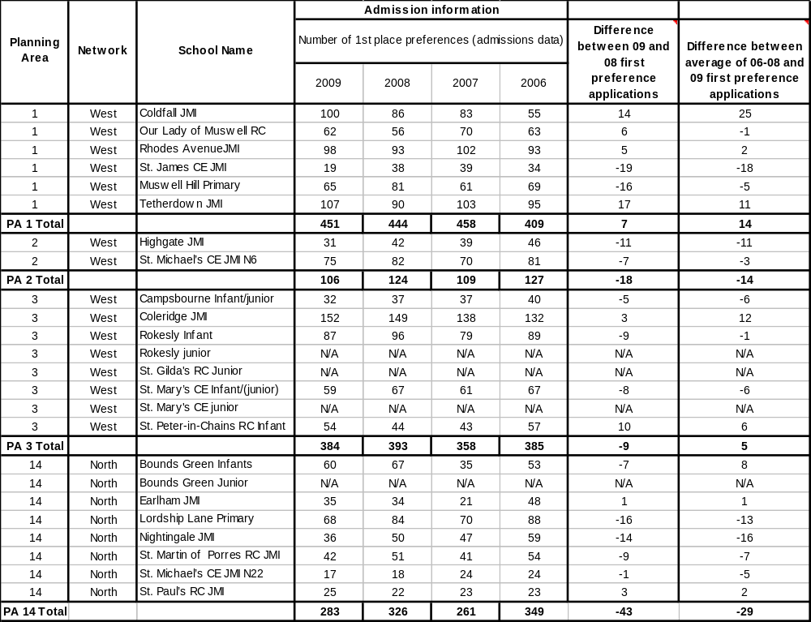

Appendix 8

Responses to Rhodes Avenue Consultation (running from
10th October to the 28th November)

119 individuals or families responded to the Rhodes Avenue consultation, and 8 ‘others’ i.e. Governing Bodies, Barnet LA, the local Police and the Diocese), making a grand total of 126 responses.

The responses from individuals/families (120) were:

Opposed to | 52 (43.3%)
In favour of | 61 (50.8%)
Impartial | 4 (4.1 %)
Inconclusive (did not complete the relevant part of the questionnaire) | 2
Total responses | 119*
*Rhodes Governing Body appeared twice so removed one.

Of the 120 responses, the figures can be summarised as;

Type of response | Number of responses | Number  of Rhodes Avenue Parents | Other* | Unknown
Online questionnaire | 64 | 13 | 51 | n/a
Consultation booklet questionnaire | 25 | 13 | 12 | n/a
Written representations (emails/letters) | 30(2 before consultation start, 3 after consultation closing date. | n/a | n/a | 30
Objections | 52 (of which 21were written reps) | 17 | 14 | 21
Supporters | 61 (of which 10 were written reps) | 6 | 43 | 12
Impartial | 4 (of which 1 written were reps) | 2 | 1 | 1
Missing (i.e. didn’t tick the box on the questionnaire indicating their opinion) | 2 | 1 | 1 | 0
Total | 119 | 26 | 59 | 34
*local residents, parent of a child not yet at school age, member of staff at another school, police, governor at another school, teacher at another school, previous Governor at Rhodes, parents at St James’ and Coldfall

OBJECTIONS
Overall, 52 individuals/families expressed opposition to the proposal. The main points made were:

- Disruption during construction works (including health and safety implications, and impact on local residents.
- Increase in traffic and congestion.
- Impact on quality of the children’s education.
- The school’s unique sense of community will be damaged by the enlargement.
- Credit crunch and current sufficiency of school places means we should not expand.
- Negative impact on Bounds Green Coldfall and surrounding schools.
- Bounds Green has capacity to be 3 forms of entry so expand there.
- Creating more places in a good school will lead to more people moving to the area for school places.
- St James C of E would like to expand so let them go ahead.

IN FAVOUR
Overall, 61 individuals/families expressed support for the proposal, and the following main points were made:

- The importance of allowing children school places close to their homes
- That there is a need for school places in the area
- That a larger school would allow more children to benefit from an excellent school
- The extra places will have a positive impact on the “black hole” that exists where it is hard to secure a local school of choice

IMPARTIAL
4 respondents were impartial about the proposal, and made the following observations:
- Does the projected growth in numbers actually exist?
- Would any required building works actually be completed given the current economic situation?

RESPONSES OTHER THAN FROM INDIVIDUALS/FAMILES

8 representations were received from Governing Bodies of local schools, the Diocese of London Board for Schools, Barnet Council, a Barnet Primary School and the Police. 4 were opposed, 2 were impartial and 1 was in (overall) support of the expansion.

Representations from the Governing Bodies of the following schools were submitted:
- Our Lady’s of Muswell Hill.
- Coldfall primary school.
- St James C of E.

The main objections from these Governing Bodies were:

- Tetherdown, Coldfall and Coleridge have all recently been expanded. Expanding Rhodes Avenue could negatively impact theses schools.
- The consultation lacks information on the impact of expansions that have already taken place
- A harsher economic environment will have an impact on the housing market reducing demand for school places.
- There are no new housing developments planned.
- Bounds Green has the capacity to become 3 forms of entry and expanding Rhodes will have a negative impact on this school.
- Educational - (greater flexibility within the school for specialisation etc).
- Social – (allowing another 30 children to have access to a school of high standards).
- Financial – (economies of scale).
- Moral - (there is a reason for the authority now to consider St James as a very real alternative to the Rhodes Avenue proposal)

An objection from the Diocese of London Board for Schools was submitted. The main objections and concerns of this objection were:

- Local Authorities long standing discussions and commitment regarding the expansion of St James.
- Quality of education – (St James C of E is a popular and successful school and meets the criteria for expansion as set out by the DSCF).
- Popularity of school – (St James C of E is oversubscribed).
- Desirability of a Two Form Entry School – (economies of scale and the feeling that it is better for the Local Authority to expand a one form of entry school than a 2 form of entry school).
- Requirement to keep a balance – ( the Local Authority is required to keep in mind the balance of denominational provision, as recent expansions have been taken place amongst the community schools)

A representation from Rhodes Avenue Primary School Governing Body was received requesting more information. They have reserved the right to express a firm opinion following further information, including the outcome of the feasibility study

Barnet Council also responded commenting that “Overall, we would not have any formal objection to the expansion as there is clearly pressure for places in that area of Haringey. Our only concern would be the impact on Hollickwood School, which is near the Haringey boundary and currently has a number of empty places. Further capacity at Rhodes Avenue would probably only exacerbate this”.

A representation in (overall) support of the proposal from the local Police was submitted. The police said:

“This proposal is good as it meets the needs of the local community; however consideration needs to be given to how the extra pupils will arrive at the school as there are already issues with parking when at the start and end of the school day”.

A representation from a local Barnet School was received – Hollickwood Primary school. They have objected to the proposed expansion on the basis that their school rolls are not full and, because of their proximity to Rhodes Avenue School, any expansion will have a negative impact on their rolls, reducing them still further.

This map is produced using ordnance survey digital map data under licence number 100019199 Copyright © Crown Copyright. No unauthorised reproduction is allowed. (2008) The Children and Young People's Service

Appendix 6 Key Stage 2 results from 2003-2008
This map is produced using ordnance survey digital map data under licence number 100019199 Copyright © Crown Copyright. No unauthorised reproduction is allowed. (2008) The Children and Young People's Service

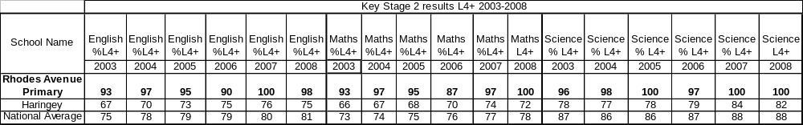
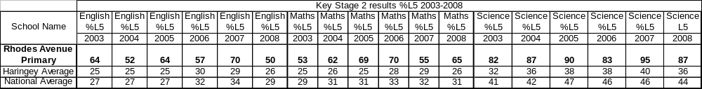

Appendix 7 First place preference information from 2005-2009

Appendix 8 Ofsted Report- 6th March 2007

Inspection Report
Unique Reference Number | 102128
Local Authority | Haringey
Inspection number | 286280
Inspection date | 6 March 2007
Reporting inspector | Barry Jones
This inspection of the school was carried out under section 5 of the Education Act 2005.

Type of school | Primary
School category | Community
Age range of pupils | 3–11
Gender of pupils | Mixed
Number on roll (school) | 472
Appropriate authority | The governing body
Date of previous school inspection | 29 April 2002

School address | Rhodes Avenue
 | London
 | N22 7UT
Telephone number | 020 8888 2859
Fax number | 020 8881 7090
Chair | Ms Alison Vaughan
Headteacher | Mrs Christine Witham

Introduction
The inspection was carried out by an Additional Inspector.

Description of the school
Rhodes Avenue is a larger-than-average primary school. It has a higher proportion of pupils from minority ethnic backgrounds than most schools but none are at the early stages of learning English. The school serves an area that is more advantaged than most. Pupils enter school with attainment that is above average. The deputy has been acting headteacher for periods in the last year while the substantiative headteacher has had compassionate leave. Currently, the headteacher is able to attend for part of each week.
Key for inspection grades
Grade 1 | Outstanding
Grade 2 | Good
Grade 3 | Satisfactory
Grade 4 | Inadequate

Overall effectiveness of the school
Grade: 1
This is an outstanding school that continually strives for, and achieves excellence. Parents' high aspirations for their children are met and consequently they value the work of the school. They are overwhelmingly positive about the school and as one parent wrote, `My son has grown in confidence in his studies and in himself since coming to Rhodes Avenue. The teaching is first-rate'.
Children make a good start in the Foundation Stage and make good progress as a result of the good teaching. By the end of Year 6, pupils have attained standards which have been exceptionally high in the four years prior to 2006. In these years, from their above average starting points pupils have made excellent progress in English, mathematics and science. In the 2006 national tests there was a slight dip in performance. Pupils in Year 6 again made excellent progress in mathematics, science and reading. However, fewer pupils than expected attained the highest level in writing. The school has developed a number of strategies to correct this and progress has been accelerated. However, it is not possible to be precise about the amount of the improvement made. This is because the school is just beginning to collate the extensive assessment data that it has for each pupil to chart progress made by pupils more accurately.
The quality of teaching is consistently good. There is a high proportion of outstanding teaching for the older pupils and this underpins their excellent progress. Parents also make a significant contribution to their children's learning through support for work at home and by helping out in school. They help to enhance the curriculum, particularly in art, drama and creative writing. As a result, pupils have a rich range of experiences and enjoy school very much. They feel very safe and play their full part in making this a good place to be. They are very well prepared for the next stage in their life, both academically and socially.
The school is exceptionally well led by the headteacher and the deputy headteacher, ably supported by her senior leadership team. They have maintained high standards by a relentless drive to correct any identified slippage in performance. Actions are firmly rooted in evidence and agreed policies are implemented consistently by the whole staff. Self-evaluation is good except that the school tends to be cautious in its judgements. The school has continued to make good progress since the previous inspection and capacity to improve further is also good.

What the school should do to improve further
- Ensure that pupils achieve as well in writing as in their other basic skills.
- Ensure that there is an accurate record of the progress made by pupils.

Achievement and standards
Grade: 1
Children make good progress in the Nursery and enter Reception with good language and numeracy skills. They attain standards in the tests at the end of Year 2 which are above average. In 2006, progress in Key Stage 1 in mathematics was satisfactory only. This is because too few of the more able girls attained the highest level. The school has addressed this through a programme including support for teachers and increased monitoring of planning. Progress accelerates significantly in Key Stage 2, particularly in mathematics, as a result of some outstanding teaching. Even given the high starting points, the average value added by the school in English, mathematics and science is consistently in the top 10% nationally and is usually in the top 5%. There was a dip in the writing results in 2006. The school has reviewed its provision, has created an extra group for literacy in Year 6, and has organised additional writing workshops for more able pupils. The workshops benefit from the input of a parent who has considerable knowledge and expertise in children's literature. Parents also support the reading programme extensively and contribute to the high standards. There are no underachieving groups. Pupils with learning difficulties and disabilities make the same progress as their classmates.

Personal development and well-being
Grade: 1
Pupils' personal development and well-being, including their spiritual, moral, social and cultural development, are outstanding. They develop into responsible and mature young people. They make an excellent contribution to school life and to the wider community. The quality of relationships and behaviour in the school are very good. A few parents expressed concerns about bullying. The school has made combating bullying a high priority, and the school council has made an effective contribution to the debate about procedures to be adopted. Pupils say that there are few incidences and have confidence in the adults to resolve these. They believe that `peer mediators' are respected by fellow pupils. As one pupil said, `It is not a problem. If anything does happen the teacher will sort it'.

Quality of provision

Teaching and learning
Grade: 2
Teaching and learning are good and this is also the school's judgement. There are examples of excellent teaching in all years but more frequently for older pupils. The teachers have good subject knowledge, give clear explanations and use questioning well to help pupils develop their ideas and thinking. They make good use of resources including interactive whiteboards. This adds interest to lessons, increases pupils' motivation and consequently they say, `We learn in lots of different ways' and `It is fun but you still learn'. Pupils with learning difficulties and disabilities are very effectively supported in literacy and numeracy lessons by class teachers and by specialist staff. The school has analysed the reasons for the lower performance in writing. One outcome is that there is more attention being given to constructive feedback to pupils through marking of their work. The school recognises that there has been insufficient challenge in mathematics for the most able pupils in Key Stage 1 and this has been identified as an area for development. Pupils also say that they are appreciative of the help that they receive at home.

Curriculum and other activities
Grade: 1
The curriculum is outstanding in the Foundation Stage and in the main school. The school's excellent provision for health education, sports and art have been acknowledged by nationally accredited awards. Consequently, the pupils have an excellent understanding of healthy living issues and produce some outstanding artwork. The many opportunities to listen to uplifting music, to sing, investigate in science and explore art and drama create moments of awe and wonder for the pupils. Many parents provide invaluable support including for special curriculum weeks and projects, local history week, art days and pottery. The school continues to develop the curriculum and has introduced French for the older pupils. The opportunities for pupils to write creatively have been increased considerably this year. There have also been improvements in the provision for pupils' personal and social education that contribute to the high standards. There is a rich range of extra-curricular activities and many visitors come to the school to share their experiences.

Care, guidance and support
Grade: 2
Care, guidance and support are good. There are very good induction procedures into the Nursery and Reception classes that ensure that children settle quickly into the routines of the school. The school works hard and successfully at raising the self-esteem of all pupils. Staff know pupils well and there is effective working with other agencies to support vulnerable pupils. The school works also very well with local secondary schools to ensure a smooth transition at the end of Year 6. Pupils know their targets and what they have to do to improve. The school has extensive assessment data on each individual pupil. There are good procedures for sharing this data with between staff as necessary. The school is developing its tracking of pupils' progress, but until this is fully established it cannot be sure that it identifies slippage in performance as early as it might in all cases. For instance, it does not have a complete picture of the progress of the small minority ethnic groups.

Leadership and management
Grade: 1
Leadership and management are outstanding. The headteacher has a clear vision for the school and this is shared by governors, staff and pupils. The very good structures and procedures mean that the school is able to continue to grow and operate smoothly in the absence of the headteacher for significant periods. This is also possible because the school has some strong middle managers who contribute significantly to the strong pastoral care and very good leadership for subjects. The school makes very effective use of data from external sources such as Ofsted and the local authority to raise standards and achievement. It has been used well, for instance, to target support effectively in Key Stage 2 and has contributed to the excellent progress made by pupils. The governors are very actively involved in the school and hold it to account very well. They have instigated a rolling programme of questionnaires for both parents and pupils. These are acted upon and consequently most parents and pupils feel that their views are valued.

Annex A

Inspection judgements
Key to judgements: grade 1 is outstanding, grade 2 good, grade 3 satisfactory, and grade 4 inadequate | School Overall
Overall effectiveness
How effective, efficient and inclusive is the provision of education, integrated care and any extended services in meeting the needs of learners? | 1
How well does the school work in partnership with others to promote learners' well-being? | 1
The quality and standards in the Foundation Stage | 2
The effectiveness of the school's self-evaluation | 2
The capacity to make any necessary improvements | 2
Effective steps have been taken to promote improvement since the last inspection | Yes
Achievement and standards
How well do learners achieve? | 1
The standards¹ reached by learners | 1
How well learners make progress, taking account of any significant variations between groups of learners | 1
How well learners with learning difficulties and disabilities make progress | 1
¹ Grade 1 - Exceptionally and consistently high; Grade 2 - Generally above average with none significantly below average; Grade 3 - Broadly average to below average; Grade 4 - Exceptionally low.
Personal development and well-being
How good is the overall personal development and well-being of the learners? | 1
The extent of learners' spiritual, moral, social and cultural development | 1
The behaviour of learners | 2
The attendance of learners | 2
How well learners enjoy their education | 1
The extent to which learners adopt safe practices | 1
The extent to which learners adopt healthy lifestyles | 1
The extent to which learners make a positive contribution to the community | 1
How well learners develop workplace and other skills that will contribute to their future economic well-being | 1
The quality of provision
How effective are teaching and learning in meeting the full range of the learners' needs? | 2
How well do the curriculum and other activities meet the range of needs and interests of learners? | 1
How well are learners cared for, guided and supported? | 2
Leadership and management
How effective are leadership and management in raising achievement and supporting all learners? | 1
How effectively leaders and managers at all levels set clear direction leading to improvement and promote high quality of care and education | 1
How effectively performance is monitored, evaluated and improved to meet challenging targets | 2
How well equality of opportunity is promoted and discrimination tackled so that all learners achieve as well as they can | 2
How effectively and efficiently resources, including staff, are deployed to achieve value for money | 1
The extent to which governors and other supervisory boards discharge their responsibilities | 1
Do procedures for safeguarding learners meet current government requirements? | Yes
Does this school require special measures? | No
Does this school require a notice to improve? | No

Annex B

Text from letter to pupils explaining the findings of the inspection
Thank you for your help and cooperation when I inspected your school. I spoke to some of you around the school and met a group of your school councillors. You told me how much you enjoy coming to school, that the teachers make the lessons fun and that you feel very safe there. The school councillors told me that their voice is heard. For instance, they were able to make suggestions when the school was drawing up a new anti-bullying policy. You told me that behaviour is good.
My main finding is that Rhodes Avenue is an outstanding school. It is very well led, the teaching is good and as a result pupils achieve high standards in the SATs. Your parents and carers also contribute to this. They help at home, but also in school with reading, creative writing workshops, art, pottery and special events. You play your part by being ready to learn, behaving and attending well. You also benefit from a variety of after-school clubs, trips and interesting visitors to come to the school. You have a very thriving community.
The school is continually striving to improve further. I have indicated two ways of doing this. I would like to see pupils attaining the standards in writing that they do in their reading and mathematics. I am also asking that the school uses the data it collects to follow more closely the progress that you make in your work.
Thank you again. I wish you continuing success in the future.
Barry Jones
Lead inspector
© Crown copyright 2007
Website: www.ofsted.gov.uk
This document may be reproduced in whole or in part for non-commercial educational purposes, provided that the information quoted is reproduced without adaptation and the source and date of publication are stated.
Further copies of this report are obtainable from the school. Under the Education Act 2005, the school must provide a copy of this report free of charge to certain categories of people. A charge not exceeding the full cost of reproduction may be made for any other copies supplied.
Any complaints about the inspection or the report should be made following the procedures set out in the guidance 'Complaints about school inspections', which is available from Ofsted's website: www.ofsted.gov.uk.

We could only determine if it was a Rhodes Avenue parent if they filled in an on-line questionnaire, or a hard copy questionnaire. Where we received a response in the form of a letter it was often impossible to determine if this was from a Rhodes Avenue parent or from another interested party. This means that we probably received more than 24 responses from parents/carers at the school, but we cannot ascertain exactly how many because letters don’t always indicate this information.
PLASC – Pupil Level Annual School Census
This refers to total applications – that is, irrespective of whether a first or fourth choice.
We could only determine if it was a Rhodes Avenue parent if they filled in an on-line questionnaire, or a hard copy questionnaire. Where we received a response in the form of a letter it was often impossible to determine if this was from a Rhodes Avenue parent or from another interested party. This means that we probably received more than 24 responses from parents/carers at the school, but we cannot ascertain exactly how many because letters don’t always indicate this information.

