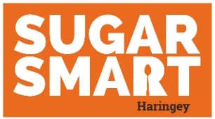
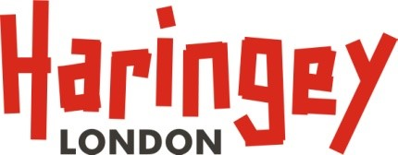

SUGAR SMART celebration guidance for Haringey Schools
Birthday parties and holiday celebrations can be fun events for students, teachers and parents. But the food offered at school celebrations can often include unhealthy choices – like cake, chocolate, biscuits and fizzy drinks. The sugar in these foods contributes to the large amount of sugar children and young people consume, and we know that on average children consume more than three times the recommended maximum of sugar. Using food as a reward also interferes with children’s natural ability to regulate their eating and encourages them to eat when they are not hungry. We are encouraging schools to focus on fun rather than food! Look below for some alternative, healthy suggestions to help you to become a SUGAR SMART school.
Events | Alternative examples or suggestions
End of term parties or celebration events | - Involve children in planning and preparing celebration. This will give them ownership of any decisions.  - Give children the opportunity to choose what activity they would like to do  - Try out a new game or creative experience, including arts, music or cooking.  - Have a longer break time or some “free choice” time  - Do a show and tell  - Host a talent show  - Eat lunch outside  - Play games in the local park or go for a walk  - Reward children for their achievements with certificates  - Play music in the classroom  - Have a disco  - Enjoy a day of arts and crafts  - Instead of food-related gifts at the end of the term, offer children gifts such as pencils, reusable water bottles, or swimming vouchers  - If you do decide to incorporate food, choose healthy options, such as:  - Chopped vegetable sticks, like celery, carrots, pepper and cucumber, with a low-fat dip, like reduced fat hummus  - Selection of fruit
School fayres or fundraisers | - Have raffles that are non-food related. This could include vouchers for local goods and services, plants, books, stationery and handmade crafts  - Sell sugar-free products at food stalls  - Rename healthy options as fun alternatives. For example, water could be called “melted snow” at Christmas Fayres. Why not also invite children to come up with their own names.
Parents bringing in birthday treats (e.g. cake) for the class | If parents wish to buy treats for the class or their child, ask them to bring treats, such as:  - Stickers, pencils  - Donating a book to the class or school library  - Fruit platters
This list is not intended to be exhaustive, and is intended as a starting point to thinking about simple changes you can make to become a SUGAR SMART school.
Any further ideas or good practice? Share them with Healthy.Schools@haringey.gov.uk
