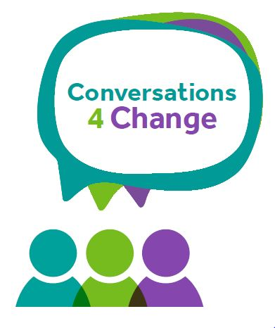
Early Help

SECTION 1 Family Information

Family Information (include all those living in the family home)
If unborn, state name as ‘unborn baby’ and mother’s name, e.g. unborn baby of Ann Smith.
Children and Young People
Name | Date of Birth | Gender  M/F | Ethnicity |  |  | Disability  (please specify if appropriate)
Parents /Carers
Name | Date of Birth | Gender M/F |  | Ethnicity | Disability  (please specify if appropriate) |  |  | Relationship to child
Main Family address (s) & contact details
Address:

Postcode:

Phone/Mobile:

E-mail:

Date of request for EH service _____________________

Please state the school/agency requesting The Early Help service _____________________

SECTION 2 Our Journey of Change

Who has contributed to our conversation? (Please indicate all those involved in the discussion, Including family/ wider family/ professionals)

Reason for Early Help Involvement ( Please describe why you believe the family would benefit from Early Help intervention)

Family Outcome Star
Area of Life | Outcome Star Score (please score each area between 1-10) | What is working Well? | What are we worried about? | What needs to happen? | Additional Comments
Physical Health
Your Wellbeing

Meeting emotional needs
Keeping your children safe
Social networks
Education & Learning
Boundaries & Behaviour
Family routine
Home & Money
Progress to work

What could happen if nothing changes? (Please detail any specific worries that you/other professionals have about the child/children now and in the future if nothing happens to reduce risks?)
How will we know if things have worked? (Please describe what you believe the parent/carer needs to do differently to convince everyone that the child/children are safe, and what will be the impact on the child/children?)

Overall as a family, how are we managing on a scale of 1-10? (Please select One option, and delete those that do not apply)

1-2 = stuck
3-4 = accepting help
5-6 = trying
7-8 = finding what works
9-10 = effective parenting

Child or young person's views and wishes

First Name(s) | Last Name(s) |  | views and wishes
Parents/Carer’s views and wishes

First Name(s) | Last Name(s) | views and wishes

Date field

Date conversation completed

