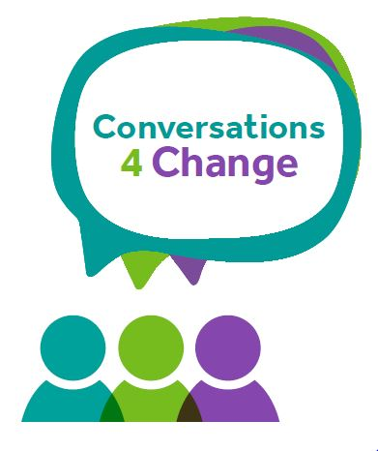
Early Help
Checking in on Change

SECTION 1 Family Information

Family Information (include all those living in the family home)
If unborn, state name as ‘unborn baby’ and mother’s name, e.g. unborn baby of Ann Smith.
Children and Young People
Name | Date of Birth | Gender  M/F | Ethnicity |  | Disability  (please specify if appropriate)
Parents /Carers
Name | Date of Birth | Gender M/F | Ethnicity | Disability  (please specify) |  |  | Relationship
Main Family address (s) & contact details
Address:

Postcode:

Phone/Mobile:

E-mail:

Contact details of people involved in the conversation (Please indicate all those involved in the discussion, Including family/ wider family/ professionals)

Your Lead Professional is:

SECTION 2 Our Journey for change

Area of Life | Outcome Star Score(please score each area between 1-10) | What is working well? | What are we worried about? | Are we still  worried?  (Please state :  YES  NO  Or PARTIALLY) | What needs to happen? | By Whom? | By When? | Comments
Physical Health
Your Wellbeing

Meeting emotional needs
Keeping your children safe
Social networks
Education & Learning
Boundaries & Behaviour
Family routine
Home & Money
Progress to work

Child or young person's views and wishes

First Name(s) | Last Name(s) |  | views and wishes
Parents/Carer’s views and wishes

First Name(s) |  | Last Name(s) |  | views and wishes

Date check in Completed___________________________________________

Your next check in will be updated on________________________________

